OCR GCE A

COMPUTER SCIENCE PROJECT

H446-03

Name : Milli Brunson

Candidate Number : 1528

<Institution Name> : 31155

Title of Project : Product recommendations and stock control

H446-03 – Project CONTENTS

Table of Contents

Table of Contents 2

A. Analysis 2

Problem outline 3

Stakeholders 3

How this problem can be solved using Computational Methods 3

Thinking Abstractly 3

Thinking Ahead 3

Thinking Procedurally 4

Thinking Logically 4

Thinking Concurrently 5

Conclusion 5

Research 5

Research into the Netflix recommendation engine 5

Research into the Amazon recommendation engine 5

Initial requirements interview 6

Updated requirements interview 7

Features of the proposed solution 9

Hardware and software requirements 10

Success criteria 11

B. Design 12

Systems diagram 12

Module Explanation 12

Proposed screen designs and usability features 14

Detailed summary of the process 16

Algorithms 16

Key variables and structures 22

Test data for development 24

Test data acceptance testing 28

Signing of on the proposal 29

C. Developing the coded solution (“The development story”) 30

Code analysis 30

Graphical user interface 30

Recommendations 30

Stock predictions 30

D. Evaluation 31

Project Appendixes 31

# A. Analysis

Problem outline  
My project is a product recommendation and predicting stock levels smart algorithm. It will use a customer's purchase history and the purchase history of other customers to determine what products a customer is most likely to purchase so the end user can go on to recommend these products. It will need to recognise buying patterns and make predictions based off them to do this. It will also look at stock level and the frequency at which items are purchased to estimate the date when stock will run out. This will allow the end user to prevent stock running out by re-ordering before the date.

Stakeholders  
The stakeholders will likely be end users who are looking to grow sales using this system, they may be business owners or sales managers. The system will help them prevent stock from completely running out, this will help grow sales as customers can only buy products if they are in stock so keeping products in stock allows more customers to buy them. The system will also suggest products a customer is likely to buy, this will help them grow their sales as they can recommend products that a customer is likely to like and want to purchase. The simple user interface means that the end user requires very little knowledge about the program itself and how it works. This expands the target audience as it will be easier to use. The end user will need to understand what the program does and the data the program requires to run, which may limit the target audience. However, the individuals using the system are likely to know this due to their job role. I have selected Katherine Northmore to personify my target audience. She sells handmade crafts online so will know what an end user would expect from a product recommendation and predictive stock levels algorithm. I have regular contact with Katherine Northmore as we attend the same sixth form. She is a suitable stakeholder as her requirements for the system are that it increases sales by suggesting recommendations and helping prevent products from going out of stock, these requirements are similar to the target audience’s requirements.

## How this problem can be solved using Computational Methods

This problem can be solved using computational methods. Abstraction plays a large part in the program as all of the data the program uses is heavily abstracted. Algorithms, specifically smart algorithms, are used to make recommendations and suggestions, and decomposition can be used to break down the problem into algorithms.

Thinking Abstractly  
Abstraction is a necessary part of solving this problem as not all data gathered about customers and stock levels will be relevant when making recommendations and estimated dates a product will run out on. Abstraction must be used to remove the unnecessary aspects of the data.

* Customers will be abstracted to a Customer ID, this ID will be unique to each customer, a customer's customer ID will remain constant between orders. All other information about the customer, for example: their name, will be ignored.
* Products will be abstracted to a Product ID. Product ID will be unique to the product, two of the same products will have the same product ID, two different products will have different product IDs. All other details about the products, for example: price, will be ignored.
* Orders will be abstracted to an order number, the product IDs of the products within that order, the customer ID of the customer who placed the order, and the date the order was placed.
* The number of products in stock will be abstracted to a number equal to or greater than 0 and the product ID. Other details, such as the supplier, will be ignored.

Thinking Ahead  
Thinking ahead is vital for solving this problem. Without the correct inputs the program will not work correctly. Recommendations and suggested dates when stock will run out could be incorrect which would negatively impact end users who are using the program to increase sales.

* The required data will be customer ID, product ID, order number, order date, order content, and the number of products in stock.
* Outputs will be product recommendations based on what the customer and other customers have previously bought, and the anticipated date a product will run out.

Thinking Procedurally  
Decomposing the problem into smaller sub-problems will make the problem easier to solve and will provide some structure when solving the problem as sub-problems can be tackled one at a time rather than attempting to solve the whole problem in one go.

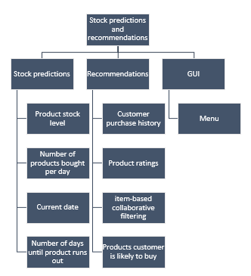

Using procedural thinking the program has been broken down into three key sub-problems, predictive ordering, product recommendations, and Graphical User Interface. Solving these sub-problems will allow the program to function correctly.

Stock predictions

* The predictive stock levels algorithm makes up one of the main sections of my project. When a product is not in stock, a customer cannot buy it, this reduces sales. The end user should be able to see the date a product is predicted to run out on so it can be re-ordered to prevent periods when the product is unavailable. Preventing these periods will increase sales.

Product recommendations

* The product recommendation algorithm makes up the other main section of my project. Product recommendation will help to increase sales by suggesting products a customer is likely to purchase. The end user should be able to see each customer ID and the products they are most likely to buy based on their purchase history, the purchase history of other customers and the ratings of the products. Customers being recommended a product they may like will increase sales.

GUI

* The Graphical User Interface is necessary for the end users to be able to interact with the program. It allows the end user to choose what they will view, for example, when a certain product will run out. The user should be shown the various options in the form of a menu.

Thinking Logically  
Thinking logically will help when solving the problem as it will show where the decision points are for branching and where loops could be implemented. This will provide some structure when solving the problem as it provides an outline of the program itself.

* The main menu is a decision point. It will give the user the option to view the predictive stock level menu or the product recommendation section. If the user selects the predictive stock level option (e.g. enters the letter “p”), the predictive stock level screen will be displayed. If the user selects the product recommendation option (e.g. enters the letter “r”,) customer ID and the product IDs of the products they are likely to like will be displayed.
* A branch will occur when a customer is predicted to order a product. It will be recorded that the customer has been predicted to like the product.

Thinking Concurrently  
Thinking concurrently will increase the efficiency of the program as it will show which tasks can be done at the same time, reducing how long tasks are waiting to be completed.

* While the predictive stock level menu is being displayed the current date will be recorded to decrease the time it takes to estimate the date a certain product will run out on.

Conclusion  
This project can be solved through computational methods making it well suited to being solved using a computer program. Computational methods provide structure, making the problem easier to solve. If the problem is solved using a program, end users will be able to see the date products will go out of stock on based on buying trends and which products a customer is likely to buy based of their purchase history, the purchase history of other customers and product ratings.

## Research

### Research into the Netflix recommendation engine

The Netflix Recommendation Engine (NRE) is the smart algorithm used by streaming company Netflix to recommend content to its users. It is highly successful with 80% of shows watched on the platform being discovered by users through the recommendation system. The algorithm considers many factors including viewing history, how long a user watched, and other users who may have similar taste. Netflix does not use demographic information like age or gender to make recommendations. Many machine learning systems are combined to make the NRE such as matrix factorisation and reinforcement learning. When a user joins the platform, they are asked to select titles they are interested in watching, this allows Netflix to make personalised recommendations from day one and avoid the “cold start” problem which arises when trying to make recommendations to a customer who has no watch history. If the user choses the skip the survey, they are recommended a wide range of content. The Netflix algorithm is very precise and considers large amounts of data, my algorithm will consider less data and so will be less precise. It will consider less data because there are less categorise of the test data I am using and it will allow for recommendations to be found faster as there is less processing required, also reducing the hardware requirements as it will require a less powerful computer. My program will consider less information when making predictions, but it will use customer ratings of the products like the NRE.

### Research into the Amazon recommendation engine

The Amazon recommendation engine is a smart algorithm user by the online retail company Amazon to recommend products to customers. The algorithm considers a number of factors to produce recommendations including a customer's recent purchases, trending items, and purchases of other customers with a similar viewing and purchase history. An item-based collaborative filtering algorithm is used to make recommendations. The amazon recommendation engine is not as successful as the Netflix recommendation with only 35% of sales being generated through their recommendation system but it is more similar to my recommendation system. Only the purchase histories of customers who have bought the same item are considered when recommending other items to a customer, this is because using the entire customer database would be inefficient. I will also use item-based collaborative filtering as there is limited information about the customers.

### Initial requirements interview

Plan  
The interview is being conducted to get an idea of what end users would require from the program. This will show which features to include and prioritise. The main areas of questioning are what makes a product recommendation algorithm successful, what makes a predictive stock levels algorithm successful, and what sort of user interface is necessary. To ensure that all aspects of the main areas are considered, and the requirements are as specific as possible, the main questions will be split into smaller questions.

What makes a successful product recommendation algorithm?

* Should other customers' purchase histories be considered?
* How personalised should the recommendations be?
* What features of a product should be considered?
* What data should be considered?

What makes a successful predictive ordering algorithm?

* What data should be considered?
* Should you be alerted when a product is close to running out?
* How will you know that the system is successful?

What sort of user interface should there be?

* What information would you like to be able to view?
* How should information be displayed?
* How should users interact with menus?

Interview transcript

Area 1: What makes a successful product recommendation system?

* Q: Should other customers’ purchase histories be considered?  
  A: Yes, it allows products that are similar to what the customer has bought to be recommended.
* Q: How personalised should the recommendations be?  
  A: It should be moderately personalised. If it isn’t personalised, they might not be recommended products they’re interested in, but if it's too personalised there might not be products to recommend.
* Q: What features of a product should be considered?  
  A: Price should be considered because a customer may consistently buy within a certain price range. Theme should be considered because the customer may be looking for a certain type of product.
* Q: What data should be considered?  
  A: There should be limited personal information about the customer for security and safety reasons.
* Q: How will you know that the system is successful?  
  A: Sales will increase when the customer is recommended the products because they are being show products they like and want to buy.

Area 2: What makes a successful predictive ordering algorithm?

* Q: What data should be considered?  
  A: How much stock there currently is, how frequently it is bought and how many items are bought, the average quantity people buy in one go.
* Q: Should you be alerted when a product is close to running out?  
  A: Yes, you should be alerted when there is 1/10th of the original stock remaining.
* Q: How will you know that the system is successful?  
  A: Products will not go out of stock because no one knew when it was going to go out of stock. Products should only go out of stock because they were not re-ordered or there were delays when the product was ordered.

Area 3: What sort of user interface should there be?

* Q: What information would you like to be able to view?  
  A: What products a customer is likely to like and when stock will run out.
* Q: How should information be displayed?  
  A: As simply and easy to read as possible.
* Q: How should users interact with menus?  
  A: The user should be able to click on screen buttons using the mouse to navigate the menus and information.

Interview review  
The interview provided good insight into what an end user would require from the program and what they require to deem the program successful. We decided that the recommended products didn’t need to be completely personalised but should be personalised enough that customers are being recommended things with the same or similar theme to previous purchases. We also decided that alerting when there is 1/10th of the original stock remaining may not be useful as it provides very little information about when the product may run out as, if it is an unpopular item, 1/10th of the original stock may be enough for multiple weeks or months therefore there is no benefit in alerting the user. We decided that a simple user interface that consists of onscreen buttons the user interacts with using the mouse is the best option for a graphical user interface. This will make the program more intuitive, and easy to interact with and navigate.

### Updated requirements interview

Plan  
This interview is being conducted to get a more in-depth idea of the requirements of the GUI and the information displayed to the user. This will create more specific requirements which will provide more structure for solving the problem.

Graphical User Interface requirements.

* Should colours be used if any?
* If yes, what colours?
* How many menus should there be?
* Should there be a home screen?
* If yes, what should the home screen display?
* Should there be a search bar for the user to search the data with?
* If yes, what should the user be able to search by?

Data to be displayed to the user.

* Should the probability of how likely a customer is to purchase an item be displayed?
* Should there be a limit on how many recommended products are displayed per customer?
* How customer and product information should be set out?

Interview transcript

Area 1: Graphical User interface

* Q: Should colours be used if any?   
  A: Yes, so you can distinguish between buttons and the background
* Q: If yes, what colours?  
  A: Shades of the same colour instead of lots of colours because lots of colours may make it confusing to use.
* Q: How many menus should there be?   
  A: There should be a menu with buttons to access the stock and recommendation sections. The buttons should say which part they lead to. There should be as few menus as possible because too many menus will make it confusing to use.
* Q: Should there be a home screen?  
  A: Yes
* Q: If yes, what should the home screen display?  
  A: Buttons to access the stock and recommendation sections.
* Q: Should there be a search bar for the user to search the data with?  
  A: Yes, otherwise it will be hard to find what you’re looking for.
* Q: If yes, what should the user be able to search by?   
  A: In the recommendation section you should be able to search by customer ID, in the stock section you should be able to search by product ID.

Area 2: data to be displayed to the user.

* Q: Should the probability of how likely a customer is to purchase an item be displayed?  
  A: No, the actual probability isn’t important and might make it confusing to use, it should just show the products a customer is likely to buy.
* Q: Should there be a limit on how many recommended products are displayed per customer?  
  A: No, it should be possible to see all the products a customer may like because then more products can be recommended which is more likely to increases sales.
* Q: How should customer and product information be set out?   
  A: The order the information is displayed in isn’t important if you can search by customer ID or product ID.

Interview review  
This interview has established the features of the graphical user interface and what data that should be displayed to the user.  
Home screen: this should be the screen that the program opens to. Displays the two buttons to access the stock and recommendation sections. Text should contrast the background so it's easy to read.  
Buttons: should have a label so the user knows what they lead to. Should be a different colour to the background to make them easy to see.   
Search bar: It should be at the top of the screen below the title. It should also be a different colour from the background so it's easy to see. In the recommendations section the user should be able to search using customer IDs and an error message should be displayed if no ID matches to indicate to the use that there is not a customer ID that matches the one they entered. In the stock section the user should be able to search using product IDs and an error message should be displayed if no ID matches to indicate to the user that there is not a product ID that matches the one they entered.  
Recommendations: The recommendations screen should be accessed through a button found on the home screen. The customer ID should be displayed, followed by the product IDs of the products that should be recommended. The text should contrast the background to make it easy to read. It should be clear which is the customer ID and which is the product ID.  
Stock section: The stock section should be accessed through the other button found on the home screen. The product ID followed by the date it is predicted to run out on should be displayed. The text should contrast the background to make it easy to read. It should be clear which is the product ID and which is the date.

### Features of the proposed solution

Home screen: This will provide access to the recommendation and stock section of the program through buttons. It will not display which products only have 1/10th of the original stock remaining as this may be enough for multiple months depending on the popularity of the product and the quantity of the original stock.

Recommendation screen: this will display the customer ID followed by the product IDs of the products the customer should be recommended. The data will not be displayed in any particular order as the user has a search bar to allow them to search for specific customers quickly if they need to. The user will be able to search by customer ID using the search bar.

Recommendation algorithm: this will use item-based collaborative, a type of collaborative filtering, to find products a customer may like based on how similar items are, using ratings to find similar items. Cosine similarity will be used to find how similar products are based on ratings; this will allow for products similar to what a customer has already bought to be recommended.

Stock screen: this will display the product ID followed by the date the product is predicted to run out on. Product IDs will not be listed in any particular order as the user has a search bar to allow them to search for specific products quickly if they need to. The user will be able to search by product ID using the search bar.

Stock level algorithm: this will look that the frequency at which products are purchased to predict a date a product will run out on.

Search bar: this will allow the user to quickly find customers or products by searching by customer ID or product ID. This will make the program easier to use as the user will not have to sort through a list of customer and product IDs to find the one they are looking for. If there are no customer or product IDs that match the one the user searched for an error message will be displayed to inform the user of this. The search bar will be displayed at the top of the recommendation and stock screen.

Buttons: buttons will be used to allow the user to navigate the home screen and access the recommendation and stock screens. The buttons will be labelled to clearly indicate to the user which screen they lead to. There will be a button to access the recommendation screen, the stock screen and the home screen. There will also be back buttons so the user can get to the main menu from the stock and recommendation sections.

### Limitations of the proposed solution

Data: Since the recommendations will be found using an explicit recommender, customer ratings are required which could limit the programs usefulness as there may not always be ratings information. There will also need to be enough ratings for a product. If there aren’t enough ratings it may not be possible to find similarities between the product and other product or the similarities found may not be accurate. This could result in a lack of recommendations or less precise recommendations. If there is not enough data about the frequency products are purchased it may not be possible to predict the date they will run out or the date they are predicted to run out may be inaccurate, reducing the programs usefulness.

Time: The more data there is the longer the program will take to run. If there is a large amount of data, it could take more time than there is to find recommendations or predict dates.

### Hardware and software requirements

Hardware requirements

|  |  |
| --- | --- |
| Hardware | Justification |
| Monitor | To display the data and screens to the user. |
| Mouse | To interact with the buttons and search bar by allowing the user to click. |
| Keyboard | To interact with the search bar by giving the user the ability to input data. |
| 2 Gb of RAM | Most computers have 2 Gb of RAM so the program will be able to run on most computers. |
| 10 Mb secondary storage | The program requires a database to use data from, this may be quite large. The program itself won’t be particularly large so 10 Mb should be enough to store the database and the program. |
| 33MHz processor | This is the minimum required processing power for the software to run. |

Software requirements

|  |  |
| --- | --- |
| Software | Justification |
| CSV file containing product, ratings and customers | The program requires item and customer data to make recommendations. |
| CSV file contain sales and stock level data | The program requires when products were sold, how many were sold and how many are left in stock to predict when the product will run out. |
| One of the following platforms: Windows 7 or later, MacOS, Linux | Required to run python which the program will be coded in. |
| NumPy library | Makes mathematical operations easier and implements arrays with multiple dimensions. Using it makes my program more efficient as I do not need to repeat as much code. |
| Pandas library | Makes data manipulation and analysis easier and more efficient. |
| SciKit learn library | Makes it easier to find the cosine similarity between two data points. Using it will make my program more efficient as I do not need to repeat as much code or create a function to perform cosine similarity myself. |
| Sklearn library | Needed to install SciKit learn. |
| Tkinter library | This allows the user interface to have buttons that can be interacted with. |

### Success criteria

|  |  |  |  |
| --- | --- | --- | --- |
|  | Requirement | Justification | Reference |
| 1. | Item-based collaborative filtering | This will find recommendation with limited customer data. | Amazon recommendation engine. |
| 2. | Cosine similarity | This will find how similar products are allowing for recommendations to be made | Features of the proposed solution. |
| 3. | Home screen | This will allow the user to access the recommendation and stock sections. | Updated requirements interview. |
| 4. | Home screen recommendation and stock options. | This is necessary to allow the user to access the other parts of the program. | Updated requirements interview. |
| 5. | Buttons to access the recommendation screen | This allows the user to interact with the program and is better than the user typing an answer or pressing a key as there is less room for mistypes. | Initial requirements interview. |
| 6. | Button to access the stock screen. | This allows the user to interact with the program and is better than the user typing an answer or pressing a key as there is less room for mistypes. | Initial requirements interview. |
| 7. | Different colours and shades for the background, buttons, search bar and text | This will make it easier for the user to use as it will be more readable and easier to distinguish between background, buttons and the search bars. | Updated requirements interview |
| 8. | Search bar | This will allow the user to find customers and products quickly | Updated requirements interview |
| 9. | Back button to access the home screen from the recommendation screen. | This will allow the user to go back to the home screen and access other sections without having to exit the program. | Proposed solution. |
| 10. | Back button to access the home screen from the stock screen. | This will allow the user to go back to the home screen and access other sections without having to exit the program. | Proposed solution. |
| 11. | Predictive analysis algorithm | This will analyse sales data to predict when stock will run out. | Proposed solution. |
| 12. | Recommendation screen | This will allow the recommendation information to be displayed. | Initial requirements interview. |
| 13. | List of customers and products they should be recommended | This will allow the user to see which products to recommend to which customers. | Initial requirements interview. |
| 14. | Stock screen | This will allow the stock information to be displayed for the user. | Initial requirements interview. |
| 15. | List of products and the date they will run out | This will allow the user to see when each product will run out. | Initial requirements interview. |
| 16. | CSV file link | This will allow the algorithms to use data from the CSV files to make predictions and recommendations. | Proposed solution. |

# B. Design

## Systems diagram

I have decomposed by project into small sections and displayed them in a top-down modular design. This helps me to identify all the different aspects of the program before I begin my coded solution, this means I will have more guidance when coding the solution. I have used thinking ahead to determine inputs and outputs and how these will affect the program, and thinking logically to identify decision points and what decisions are required at these points.

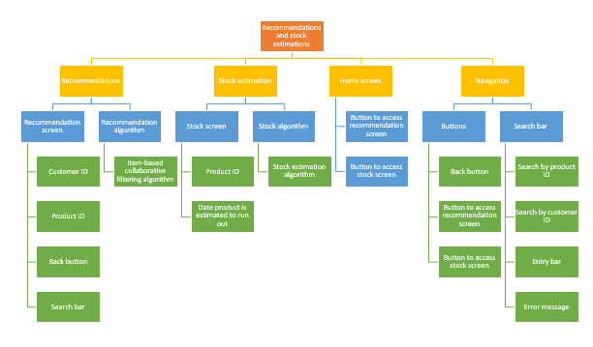

### Module Explanation

Recommendations

Recommendation screen  
Customer IDs: this displays all the customer IDs.  
Product IDs: This displays all the product IDs next to the customer who is likely to like the product.  
Back button the access the home screen: This is a button that when clicked with the mouse will display the home screen.  
Search bar: this is a search bar that can be used to search the customers by customer ID.

Recommendation algorithm  
Item-based collaborative filtering algorithm: this will use the purchase history of the customer and customers with similar purchase histories to determine other items the customer may like. It makes recommendations based on purchase histories rather than customer information. It will use cosine similarity to find how similar items are.

Stock predictions

Stock screen  
Product ID: this will display all product IDs  
Date the product is predicted to run out on: This displays the date that the product is predicted to run out on. It will display the date next to the product ID of the product.  
Back button to access the home screen: This is a button that when clicked with the mouse will display the home screen.  
Search bar: this is a search bar that can be used to search the products by product ID

Stock algorithm  
Stock estimation algorithm: this is an algorithm that will use sales data to predict the data products will go out of stock on.

Home screen

Button to access the recommendation screen: When clicked with the mouse, the recommendation screen will be displayed.  
Button to access the stock screen: When clicked with the mouse the stock screen will be displayed.

Navigation

Buttons  
Back buttons: when clicked with the mouse the home screen will be displayed  
Button to access the recommendation screen: When clicked with the mouse the recommendation screen will be displayed.  
Button to access the stock screen: When clicked with the mouse the stock screen will be displayed.

Search bar  
Search by product ID: When characters are entered into the search bar, the product IDs will be searched to find IDs that are similar or match exactly. If none are found an error message is displayed.  
Search by customer ID: When characters are entered into the search bar, the customer IDs will be searched to find ID that are similar or match exactly. If none are found an error message is displayed.  
Entry bar: This will be the bar that the user enters the item they are searching for in.  
Error message: This will be displayed if the item being searched for can’t be found.

### Data tables for all required tables

Rcdpq table.  
This table contains all of the required information. It will have information about every purchase made.

|  |  |  |  |  |
| --- | --- | --- | --- | --- |
| Customer ID | Product ID | Rating | Date purchased | Quantity purchased |
| 1 | A | 5 | 11/02/2022 | 1 |
| 2 | B | 3 | 12/02/2022 | 3 |
| 3 | C | 4 | 12/02/2022 | 2 |

Stock table.  
This table contains all of the information about stock levels.

|  |  |
| --- | --- |
| Product ID | Quantity in stock |
| A | 8 |
| B | 4 |
| C | 1 |
| D | 10 |

Product-customer table.  
This table will contain each customer rating for each product.

|  |  |  |  |  |
| --- | --- | --- | --- | --- |
| Customer IDs | 1 | 2 | 3 | 4 |
| Product IDs |  |  |  |  |
| A | 5 | 3 | - | 4 |
| B | - | 3 | 1 | - |
| C | 3 | - | 4 | 3 |

Customer has bought table.  
This data will contain all of the products a certain customer has bought.

|  |  |  |
| --- | --- | --- |
|  | Product ID | Rating |
| 0 | 1 | 3 |
| 1 | 2 | 4 |
| 2 | 3 | 5 |

Stock levels table

|  |  |
| --- | --- |
| Product ID | In stock |
| A | 10 |
| B | 4 |
| C | 32 |

Similar to what a customer has already bought table  
This table will display the product ID and similarity score of products similar to what a customer has already bought.

|  |  |  |  |  |
| --- | --- | --- | --- | --- |
|  | Product A | Product B | Product C | Product D |
| Product D | 0.6 | 0.0 | 2.3 | 3.5 |
| Product F | 2.4 | 2.1 | 0.2 | 0.1 |
| Product K | 0.7 | 0.1 | 2.2 | 3.2 |
| Product G | 0.4 | 0.2 | 0.6 | 1.0 |

### Entity relationship diagrams

Customer, order, product, date and rating entity relationship diagram

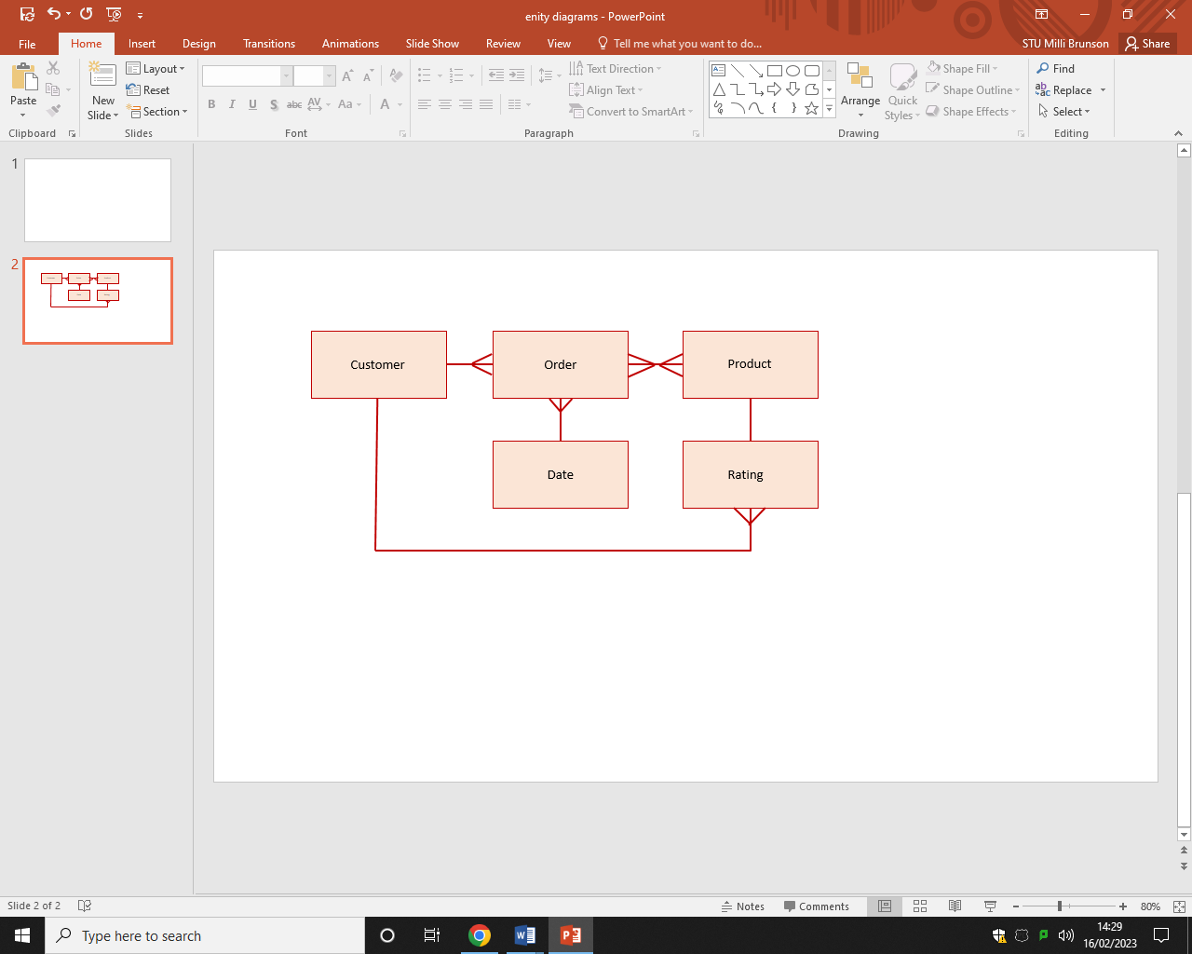

Customer-recommendations entity relationship diagram

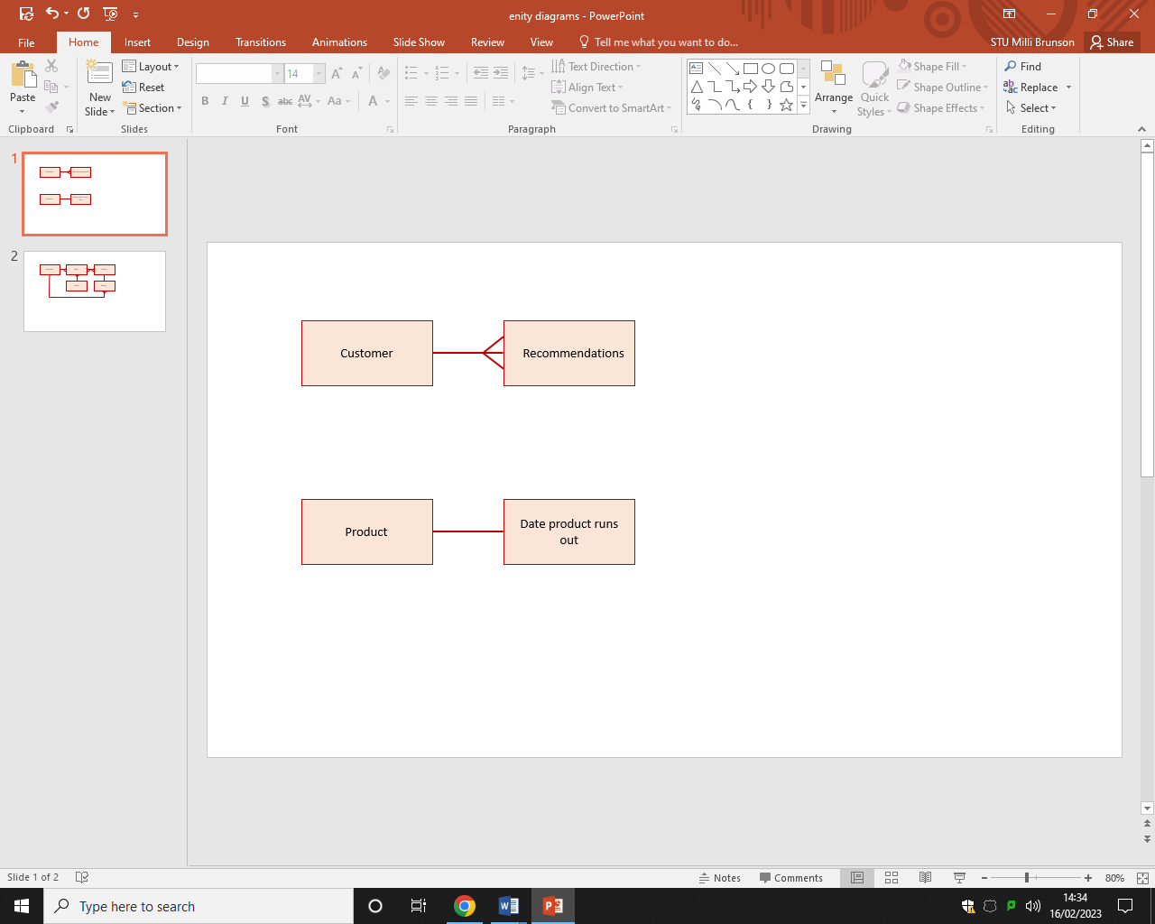

Product-predicted run out date entity relationship diagram

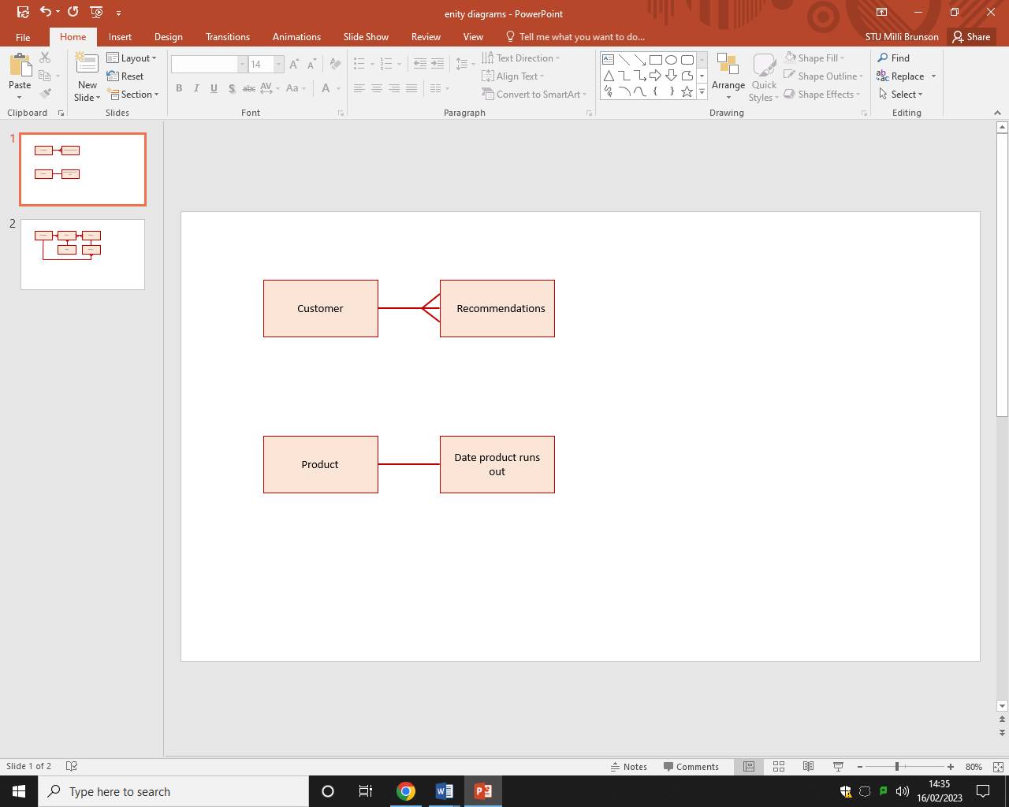

### Proposed screen designs and usability features

Clear title to tell the use which part of the program they are viewing.

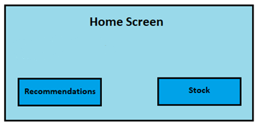Home screen

Button to access the recommendation screen. When clicked the recommendations screen will be displayed. Different colour and border make it clear that it is not part of the background. Darker shade of blue is used as the most common forms of colour-blindness can see blues.

Button to access the stock screen. When clicked on the stock screen will be displayed. Different colour and border make it clear that it is not part of the background. Darker shade of blue is used as the most common forms of colour-blindness can see blues.

Light blue used for the background to help distinguish between background and button. Blue is used as the most common forms of colour-blindness can see blues.

Clear title to make it clear to the user that they are in the recommendations section.

Recommendations screen

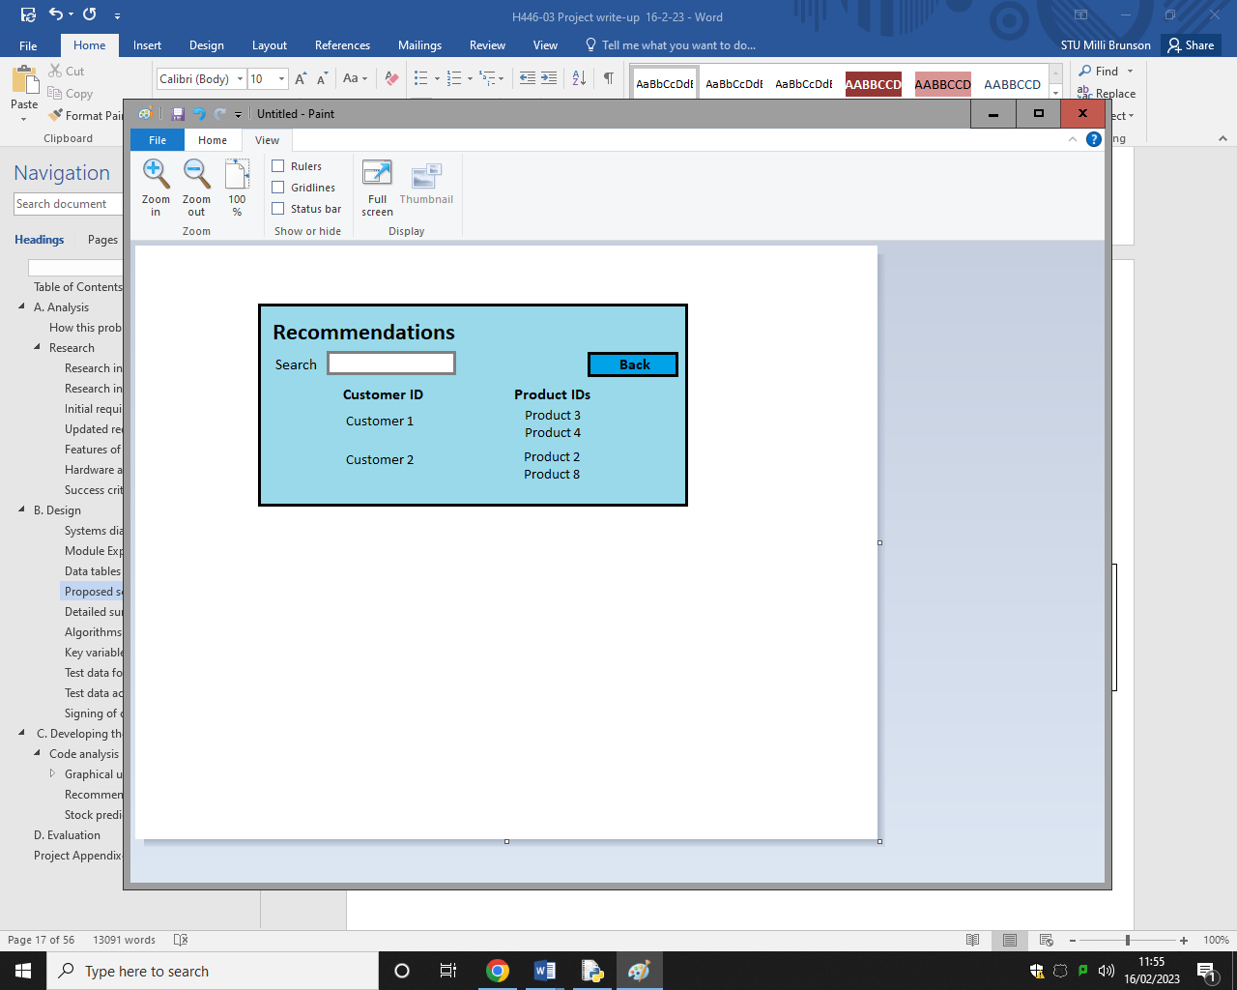

Search bar to allow the user to search for a specific customer ID. The heading tells the user that it is a search bar. The different colour makes it stand out so it is clearer to the user.

Back button to access the home screen. Border that gives the impression that it is raised to make it clear to the user that it can be clicked. When clicked the home screen will be displayed. Different colour to the background to make it easier for the user to see.

Product IDs listed on the right under the heading “Product ID” to make it clear to the user what they are.

Customer IDs listed on the left under the heading “Customer ID” to make it clear to the user what they are.

Stock screen

Clear title to make it clear to the user that they are in the stock section.

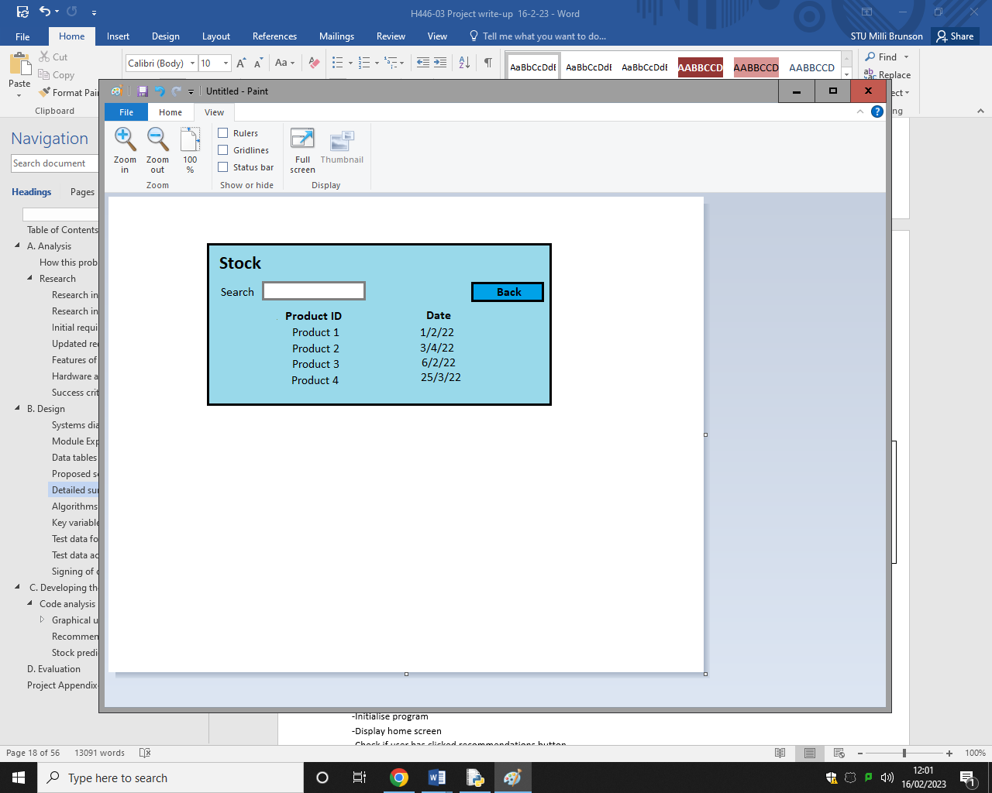

Back button to access the home screen. The border gives the impression that it is raised to make it clear to the user that it can be clicked. When clicked the home screen will be displayed. Different colour to the background to make it easier for the user to see.

Search bar to allow the user to search for a specific product ID. The heading tells the user that it is a search bar. The different colour from the background makes it stand out so it is easy to spot.

Product IDs listed on the left under the heading “Product ID” to make it clear to the user what goes in that column.

Dates listed on the right under the heading “Date” to make it clear to the user what goes in that column.

### Detailed summary of the process

Home screen  
-Initialise program  
-Display home screen  
-Check if user has clicked recommendations button  
-If user clicks recommendations button, display the recommendations screen.  
-Check if the user has clicked the stock button  
-If the user clicks the stock button display the stock screen.  
-If no buttons are clicked, continue to display the home screen.

Recommendation screen   
-Display when recommendations button is clicked on the home screen.   
-Check if user has clicked the back button   
-If the user has clicked the back button, display the home screen.   
-Check to see if the user has entered text into the search bar   
-If text has been entered into the search bar, search the customer ID list for matching or similar customer IDs   
-If matching or similar customer IDs are found, display them   
-if no buttons are clicked continue to display the recommendation screen

Stock screen   
-Display when stock button is clicked on the home screen   
-Check if the user has clicked the back button   
-If the user has clicked the back button display the home screen   
-Check to see if the user has entered text into the search bar   
-If text has been entered into the search bar search the product ID list for matching or similar product IDs   
-If matching or similar product IDs are found display them   
-If no buttons are clicked continue to display the stock screen

Controls  
-When buttons are clicked on with the cursor, display the appropriate screen  
-Use the mouse cursor and mouse left click to click on buttons and the search bar  
-Use the keyboard to enter text into the search bar

### Algorithms

Home screen

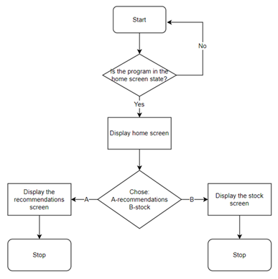

Recommendations screen

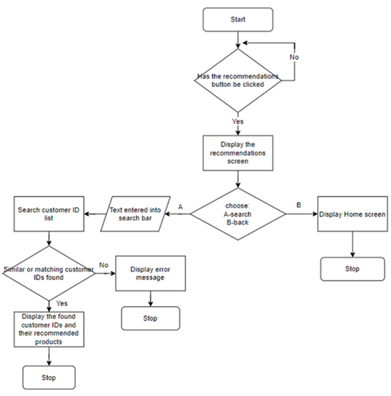

Stock screen

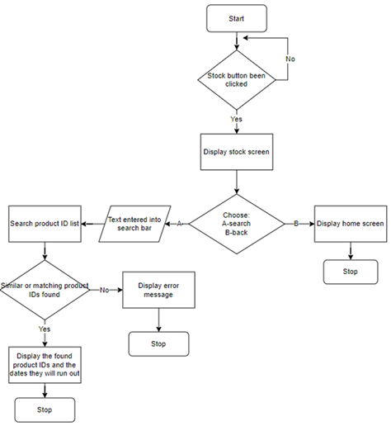

Search function

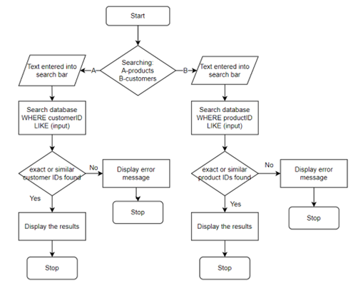

Item-based collaborative filtering algorithm

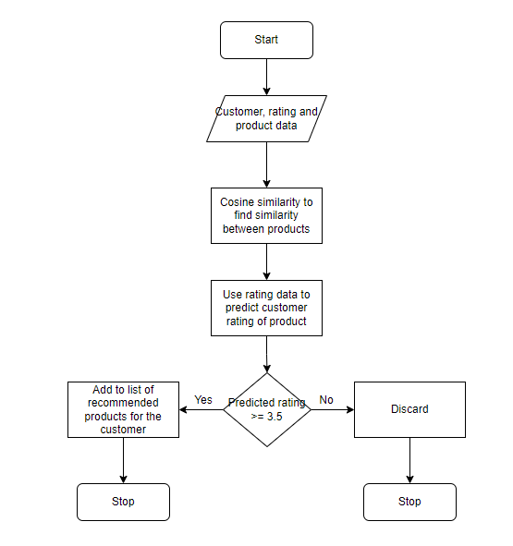

|  |  |
| --- | --- |
| Predicting stock levels | Inventory forecasting algorithm |
|  |  |

Full program flowchart

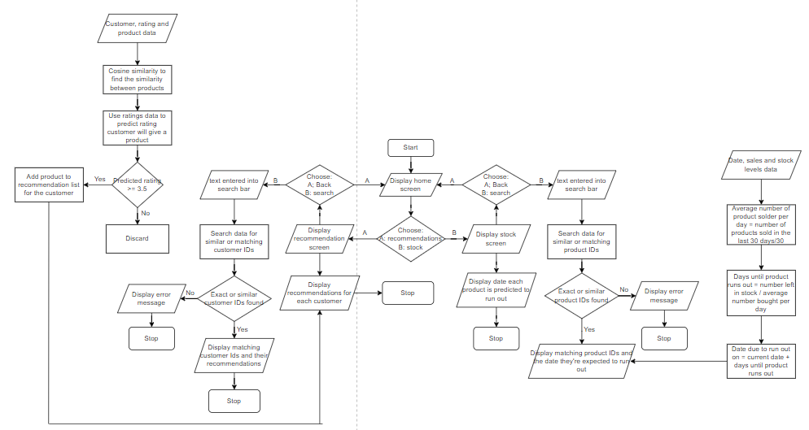

### Key variables and structures

|  |  |  |  |  |
| --- | --- | --- | --- | --- |
|  | Name | Data type | Explanation | Justification |
| Home screen |  |  |  |  |
| procedure | homescreen | N/A | Displays the home screen when called | The home screen is necessary for the user to view the home screen and access the stock and recommendation screens.  Use of a produced to display the home screen reduces the amount of repeated code and makes the code easier to read. |
| Constant | btn_rec | N/A | Creates a button labelled recommendations that when clicked displays the recommendations screen. | This button is necessary for the user to access the recommendations screen. |
| constant | btn_sto | N/A | Creates a button labelled stock that when clicked displays the stock screen. | This button is necessary for the user to access the stock screen. |
| procedure | closehome | N/A | Closes the home screen tab | Closing the home screen tab reduces the number of windows open at the same time making the program less confusing and easier to use. |
| procedure | recscreen | N/A | Imports the recscreen file when called. | Allows the recommendation button to call the recommendation screen procedure which is defined in the recscreen file. |
| procedure | stockscreen | N/A | Imports the stockscreen file when called. | Allows the stock button to call the stock screen procedure which is defined in the stockscreen file. |
| Stock screen |  |  |  |  |
| procedure | stockscreen | N/A | Displays the stock screen when called | The stock screen is necessary for the use to view stock information.  Use of a procedure to display the stock screen reduces the amount of repeated code and makes the code easier to read. |
| Constant | back_btn | N/A | Displays the home screen when clicked. | Creates a button that allows the using to go back to the home screen from the stock screen without having to exit and to-open the program. |
| procedure | closestock | N/A | Closes the stock screen. | Closing the stock screen tab reduces the number of windows open at the same time making the program less confusing and easier to use. |
| Recommendations screen |  |  |  |  |
| procedure | recscreen | N/A | Displays the recommendation screen when called. | The recommendations screen is necessary for the user to view recommendation information.  Use of a procedure to display the recommendations screen reduces the amount of repeated code and makes the code easier to read. |
| Constant | back_btn | N/A | Displays the home screen when clicked | Creates a button that when clicked displays the home screen. |
| procedure | closerec | N/A | Closes the recommendation screen | Closing the recommendation screen reduces the number of windows open at the same time making the program less confusing and easier to use. |
| Recommendation algorithm |  |  |  |  |
| constant | rcdpq | N/A | Links test data csv file to the program. | Allows for operations to be performed on and using the test data. |
| CSV file | rcdpq.csv | N/A | Contains the test data | Provides the test data for program to use. |
| variable | rcdpq_10 | N/A | Data frame contain information about only products with 10 or more ratings | Allows for operations to be performed on and using this data frame |
| Data frame | customer_bought | N/A | Contains all products a customer has bought and their rating | Allows for recommendations to be made based on customer purchase histories. |
| list | customer_nb | N/A | Contains information on which products a customer has not bought | Allows customer to be recommended products they haven’t already bought |
| Data frame | product_similarity | N/A | Stores how similar every product is compared to every other product. | Allows customers to be recommended products that are similar to what they’ve already bought. |
| variable | predicted_rating | float | Stores the customers predicted rating for the product. | Predicted customer ratings are used to determine which products to recommend. |
| list | ci_list | N/A | Stores the list of customer IDs. | List is required to display the customer IDs in the listbox. |
| list | pr_recs_list | float | Stores the list of products to recommend to a customer | List is required to display the product IDs in the listbox. |
| Predictive analysis algorithm |  |  |  |  |
| constant | stock | N/A | Links test data csv file to the program. | Allows for operations to be performed on and using the test data. |
| CSV file | stock.csv | N/A | Contains the test data | Provides the test data for program to use. |
| constant | rcdpq | N/A | Links test data csv file to the program. | Allows for operations to be performed on and using the test data. |
| CSV file | rcdpq.csv | N/A | Contains the test data | Provides the test data for program to use. |
| list | product_list | N/A | Contains all of the product IDs from the CSV file. | Allows the program to loop for every product in the test data. |
| Data frame | thirty_days | N/A | Contains all of the data from rcdpq csv file where the purchase date is between the start and end data | Allows the relevant data to be used in calculations |
| variable | days_left | integer | Stores the number of days an item has left before it goes out of stock | Allows the predicted out of stock date to be calculated |
| variable | out_of_stock_date | datetime | Stores the date the product is predicted to go out of stock on | Storing the date allows it to be added to the list later. |
| list | pi_list | N/A | Stores the product ID. | Must be stored as a list so the product IDs can be displayed in the listbox. |
| list | date_list | datetime | Stores the predicted out of stock dates | Must be stored as a list so the dates can be displayed in the listbox. |

### Test data for development

**Navigation**

Home screen

|  |  |  |
| --- | --- | --- |
| Test data | Type | Justification |
| Left mouse click on recommendations button | Valid | This is how buttons in GUIs are typically interacted with so sticking to this makes the program easier to use |
| Right mouse click on recommendations button | Invalid | This is not how buttons in GUIs are usually interacted with so allowing it may make the program confusing to use. |
| Left mouse click on stock button | Valid | This is how buttons in GUIs are typically interacted with so sticking to this makes the program easier to use |
| Right mouse click on stock button | Invalid | This is not how buttons in GUIs are usually interacted with so allowing it may make the program confusing to use. |
| Left mouse click on area without buttons | Invalid | Something happening when a user clicks on a part of the screen other than a button will make the program confusing to use. |
| Right mouse click on area without buttons | Invalid | Something happening when a user clicks on a part of the screen other than a button will make the program confusing to use. |

Stock screen

|  |  |  |
| --- | --- | --- |
| Test data | Type |  |
| Left button click on back button | Valid | This is how buttons in GUIs are typically interacted with so sticking to this makes the program easier to use |
| Right button click on back button | Invalid | This is not how buttons in GUIs are usually interacted with so allowing it may make the program confusing to use. |
| Left button click on search bar | Valid | This is how buttons in GUIs are typically interacted with so sticking to this makes the program easier to use |
| Right button click on search bar | Invalid | This is not how buttons in GUIs are usually interacted with so allowing it may make the program confusing to use. |
| Search bar entry “abcde” | Valid | Some product IDs contain only letters so exclusively alphabetic inputs must be valid to allow these product IDs to be searched for. |
| Search bar entry “12345” | Valid | Some product IDs contain only numbers so exclusively numerical inputs must be valid to allow these product IDs to be searched for. |
| Search bar entry “a2b4c6” | Valid | Some product IDs contain a mix of numbers and letters so alphanumeric inputs must be valid to allow for these product IDs to be searched for. |
| Search bar entry “@%$£” | Valid | No product IDs contain special characters but there is already an error message in place for when not matching customer IDs are found so creating another error message for invalid inputs is unnecessary. |
| Typing without left mouse click on search bar | Invalid | Nothing can be inputted into the search bar before it has been selected with a left mouse click. |
| Left mouse click on area without buttons or search bar | Invalid | Something happening when a user clicks on a part of the screen other than a button will make the program confusing to use. |
| Right mouse click on area without buttons or search bar | Invalid | Something happening when a user clicks on a part of the screen other than a button will make the program confusing to use. |

Recommendations screen

|  |  |  |
| --- | --- | --- |
| Test data | Type | Justification |
| Left button click on back button | Valid | This is how buttons in GUIs are typically interacted with so sticking to this makes the program easier to use |
| Right button click on back button | Invalid | This is not how buttons in GUIs are usually interacted with so allowing it may make the program confusing to use. |
| Left button click on search bar | Valid | This is how buttons in GUIs are typically interacted with so sticking to this makes the program easier to use |
| Right button click on search bar | Invalid | This is not how buttons in GUIs are usually interacted with so allowing it may make the program confusing to use. |
| Search bar entry “abcde” | Valid | No customer IDs contain exclusively letters but there is already an error message in place for when not matching customer IDs are found so creating another error message for invalid inputs is unnecessary. |
| Search bar entry “12345” | Valid | Customer IDs contain exclusively numbers so exclusively numeric inputs must be allowed for customer IDs to be searched for. |
| Search bar entry “a2b4c6” | Valid | No customer IDs contain a mix of letters and numbers but there is already an error message in place for when not matching customer IDs are found so creating another error message for invalid inputs is unnecessary. |
| Search bar entry “@%$£” | Valid | No customer IDs contain special characters but there is already an error message in place for when not matching customer IDs are found so creating another error message for invalid inputs is unnecessary. |
| Typing without left mouse click on search bar | Invalid | Nothing can be inputted into the search bar before it has been selected with a left mouse click. |
| Left mouse click on area without buttons or search bar | Invalid | Something happening when a user clicks on a part of the screen other than a button will make the program confusing to use. |
| Right mouse click on area without buttons or search bar | Invalid | Something happening when a user clicks on a part of the screen other than a button will make the program confusing to use. |

Data

Customer ID

|  |  |  |
| --- | --- | --- |
| Test data | Type | Justification |
| “abcde” | Valid | Data type is not relevant so no actions are performed on the customer ID. |
| “12345” | Valid | Data type is not relevant so no actions are performed on the customer ID. |
| “a2b4c6” | Valid | Data type is not relevant so no actions are performed on the customer ID. |
| “@£$%” | Valid | Data type is not relevant so no actions are performed on the customer ID. |

Product ID

|  |  |  |
| --- | --- | --- |
| Test data | Type | Justification |
| “abcde” | Valid | Data type is not relevant so no actions are performed on the product ID. |
| “12345” | Valid | Data type is not relevant so no actions are performed on the product ID. |
| “a2b4c6” | Valid | Data type is not relevant so no actions are performed on the product ID. |
| “@£$%” | Invalid | Data type is not relevant so no actions are performed on the product ID. |

Date

|  |  |  |
| --- | --- | --- |
| Test data | Type | Justification |
| “abcde” | Invalid | CSV files store dates in yyyy-mm-dd format, this format can’t contain alphabetical characters. |
| “12345” | Invalid | CSV files store dates in yyyy-mm-dd format, a string of numbers does not fit this format. |
| “a2b4c6” | Invalid | CSV files store dates in yyyy-mm-dd format, this format can’t contain alphabetical characters. |
| “1000-12-3” | Valid | This is the format CSV files store dates in. |
| “@£$%” | Invalid | CSV files store dates in yyyy-mm-dd format, this format can’t contain special characters. |

Quantity

|  |  |  |
| --- | --- | --- |
| Test data | Type | Justification |
| “abcde” | Invalid | Calculations will need to be done with the quantity value, these can’t be done using alphabetical characters or strings. |
| “12345” | Valid | Calculations will need to be done with the quantity value, these require integers. |
| “a2b4c6” | Invalid | Calculations will need to be done with the quantity value, these can’t be done using alphabetical characters or strings. |
| “@£$%” | Invalid | Calculations will need to be done with the quantity value, these can’t be done using special characters. |

### Test data acceptance testing

The program is going to be continuously tested throughout its development and I will have a black box approach to the final acceptance testing so that the user experience can be simulated and my knowledge of how the system work doesn’t interfere with the testing.

|  |  |  |
| --- | --- | --- |
| What is being tested | Input | Expected outcome |
| Home screen recommendations button | Valid: left mouse click on the button labelled “Recommendations”  Invalid: left or right mouse click on any other part of the screen | Valid: the recommendations window is displayed and the home screen window closes  Invalid: home screen continues to be displayed/recommendation screen is not displayed |
| Home screen stock button | Valid: Left mouse click on the button labelled “Stock”  Invalid: left or right mouse click on any other part of the screen | Valid: the stock window is displayed and the home screen window closes  Invalid: home screen continues to be displayed/stock screen is not displayed |
| Recommendations screen back button | Valid: left mouse click on the button labelled “Back”  Invalid: left or right mouse click on any other part of the screen | Valid: the home screen window is displayed and the recommendations screen window closes  Invalid: Recommendations screen continues to be displayed/home screen is not opened |
| Recommendations search bar entry | Valid: All inputs | Valid: similar or matching customer IDs displayed if found are displayed along with the product IDs they should be recommended, if none found a message stating such is displayed |
| Stock screen back button | Valid: left mouse click on the button labelled “Back”  Invalid: left or right mouse click on any other part of the screen | Valid: the home screen window is displayed and the stock screen window closes  Invalid: stock screen continues to be displayed/home screen is not displayed |
| Stock screen search bar entry | Valid: all inputs | Valid: similar or matching product IDs are displayed along with the date they are expected to run out on, if none found a message stating such is displayed |
| Current date | N/A | Current date used to make predictions about when products will go out of stock |
| Database for recommendations | Valid: database containing customer IDs, product IDs, date items were purchased and the quantity they were purchased in  Invalid: database does not contain customer IDs, product IDs, date information or quantity information | Valid: recommendations based of customer purchase histories can be made.  Invalid: not enough data to make product recommendations. |
| Recommendation algorithm | Valid: data contains customer IDs, product IDs and information about customer ratings.  Invalid: data that does not contain customer IDs, product IDs and/or information about customer ratings | Valid: predicted every customer rating for every product they haven’t bought  Invalid: doesn’t predicted every customer rating for every product they haven’t bought |
| Recommendations | Valid: data containing predicted ratings for each product by each customer Invalid: data that does not contain customer predicted ratings for each product by each rating. | It will be difficult to test how accurate the recommendations are until the program is implemented and sales data before and after implementation is collected. |
| Database for product stock levels | Valid: database containing product IDs, number currently in stock, dates items have been purchased, quantity items have been purchased in  Invalid: database that does not contain data about product IDs, number of an item currently in stock, when and the quantity of the items that have been purchased. | Valid: predictions of when a product will run out can be made.  Invalid: not enough data to make predictions of when a product will run out. |
| Predictive stock levels algorithm | Valid: data containing product IDs, dates products were purchased, how many of each product have been purchased and how many of the product are left in stock.  Invalid: data that does not contain product IDs, dates products were purchased, how many of each product have been purchased and/or how many of the product are left in stock. | Valid: produces a predicted out of stock date for each product. Invalid: doesn’t produce a predicted out of stock date for each product. |
| Predicated out of stock dates | Valid: data containing the predicted out of stock dates. Invalid: data that does not contain the predicted out of stock dates. | It will be difficult to test how accurate the predicted out of stock dates are until the program is implemented and sales data before and after implementation is collected. |

### Signing of on the proposal

I have shown my Katherine Northmore as I previously chose her to personify my target audience the screen mock ups.

Home screen

|  |  |
| --- | --- |
| What is successful | Changes to be made |
| * Clear title * Clear buttons * Clearly labelled buttons | N/A |

Recommendation screen

|  |  |
| --- | --- |
| What is successful | Changes to be made |
| * Clear title * Clear and labelled back button. * Search bar * Clear which is the list of customer IDs and which is the list of products they should be recommended | N/A |

Stock screen

|  |  |
| --- | --- |
| What is successful | Changes to be made |
| * Clear title * Clear and labelled back button. * Search bar * Clear which is the list of product IDs and which is the date that product will run out on | N/A |

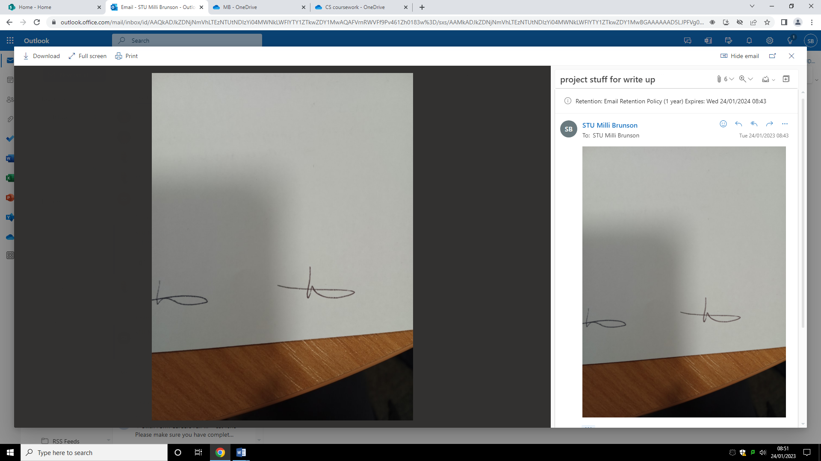Signed:

[11/1/23]

# C. Developing the coded solution (“The development story”)

Iterative development

To develop the software of my program I am following an iterative approach. I will provide a prototype of each module once it has been completed and have an interview with my stakeholder Katherine Northmore when she will be able to make comments and suggestions which will guide the next iteration. These iterations will continue until the program is completed or there isn’t enough time to create a new iteration.

## Code analysis

This part of my solution will show the development of my code. To start of my development, I have researched coded solutions to similar problems to help guide me when creating each module of my coded solution. I have found an internet resource by TkDocs that provides a basic tutorial and example of a graphical user interface made using Tkinter.

Internet resource: <https://tkdocs.com/tutorial/firstexample.html>

Structure

Tkinter automatically comes with most python distributions so it does not need to be imported

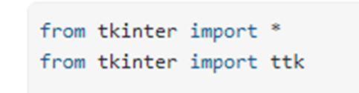

Introduces Tkinter to the code. ‘import *’ imports all functions and classes so they can be used in the code.

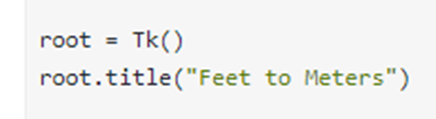

‘root.title’ give the newly created window a title.

Creates a window with the variable name ‘root’ to display the gui in

‘ttk.Frame’ creates a frame. Using frames makes widget placement easier.

‘.grid’ puts the frame in the window.

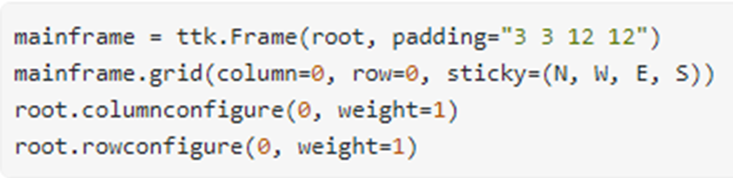

‘columnconfigure’ and ‘rowconfigure’ allow the columns and rows of the grid to expand to fill the window if it is resized.

Specifies which frame the newly created widget will be in

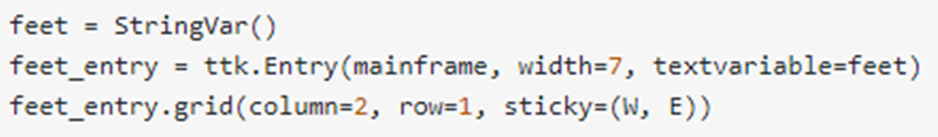

Places the entry bar in column 2 and row 1 of the grid. Column and row number starts counting from 0.

‘sticky’ specifies the placement of the entry bar within column 2 and row 1 of the grid. ‘(W, E)’ specifies that it will go from the left side to the right side of the column.



‘command=’ assigns the button an action for when it is clicked on. This example calls the procedure ‘calculate’ which has been defined earlier in the code.

‘.Button’ creates a button that can be interacted with using the cursor and left mouse click.

‘text=’ puts text on the button itself.

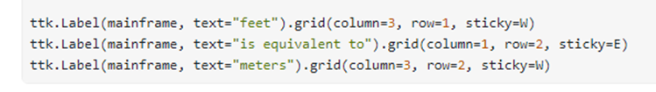

‘.mainloop()’ creates a loop that allows the window to be displayed continuously and allows the user to interact with the buttons and entry bar.

‘.Label’ allows for text to be placed in the window.

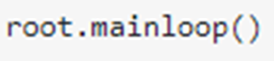

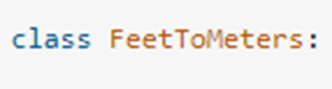

‘class’ creates a class that encapsulates all of the code necessary to display the GUI. In this example it was not necessary, but it is useful for larger and more complex GUIs.

This example will be very useful for the creation of my graphical user interface as it will allow me to create a simple interface and then build off that. The structure, use of procedures and use of classes will help to keep my code organised and easy to read, this will make reading through my code and finding errors easier.Recommendations algorithm

I have found an internet resource by Datacamp that provides a basic tutorial and overview of a simple recommendation algorithm.

Internet resource: <https://www.datacamp.com/tutorial/recommender-systems-python>

‘import’ introduces pandas to the code

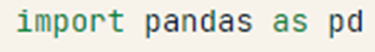



‘pd.read’ uses panda to read the csv file called ‘move_metadata.csv’



‘.mean()’ finds the mean rating across all of the data using pandas



‘.quantile90.90)’ finds the number of votes required to be in the 90th percentile of best rated films

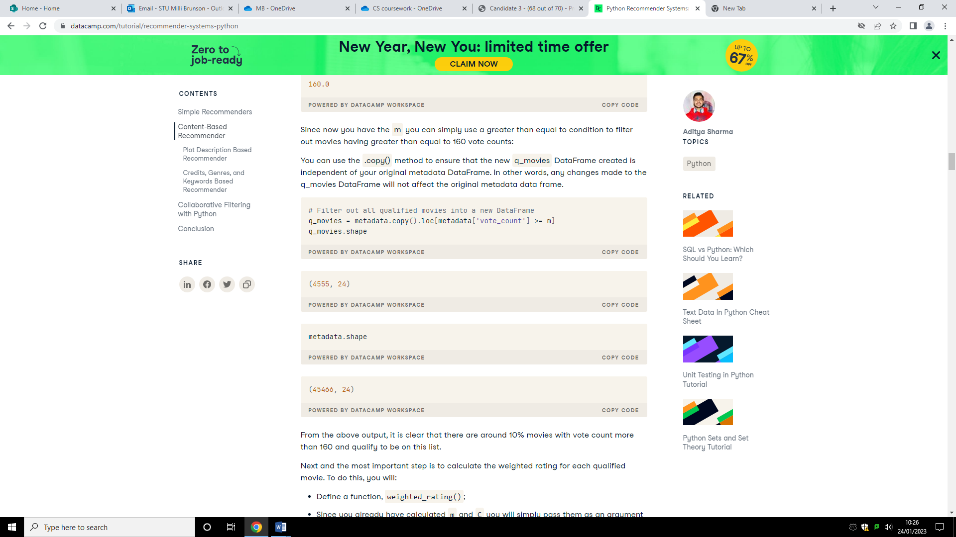

Removes films with a rating less than m from the new dataframe

‘metadata.copy()’ creates a new dataframe that is independent of the old one

‘.shape()’ obtains the number of rows and columns (the shape) of the dataframe

Passes m and c as arguments into the function

‘def weighted_rating’ creates a function for finding the weighted rating of each film

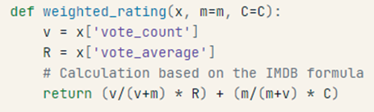

Calculates and returns the value of the weighted rating

Selects vote_count and vote_average from the dataframe

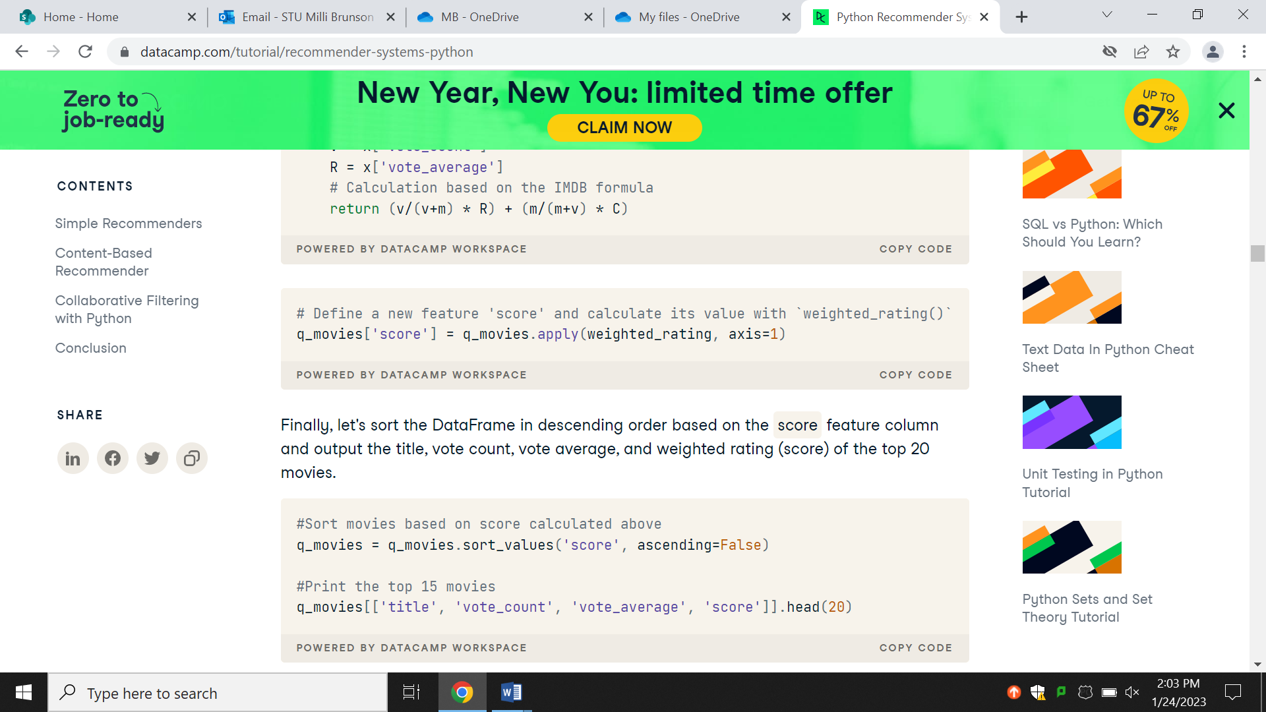

Calculates the value of ‘score’ using the weighted_rating function

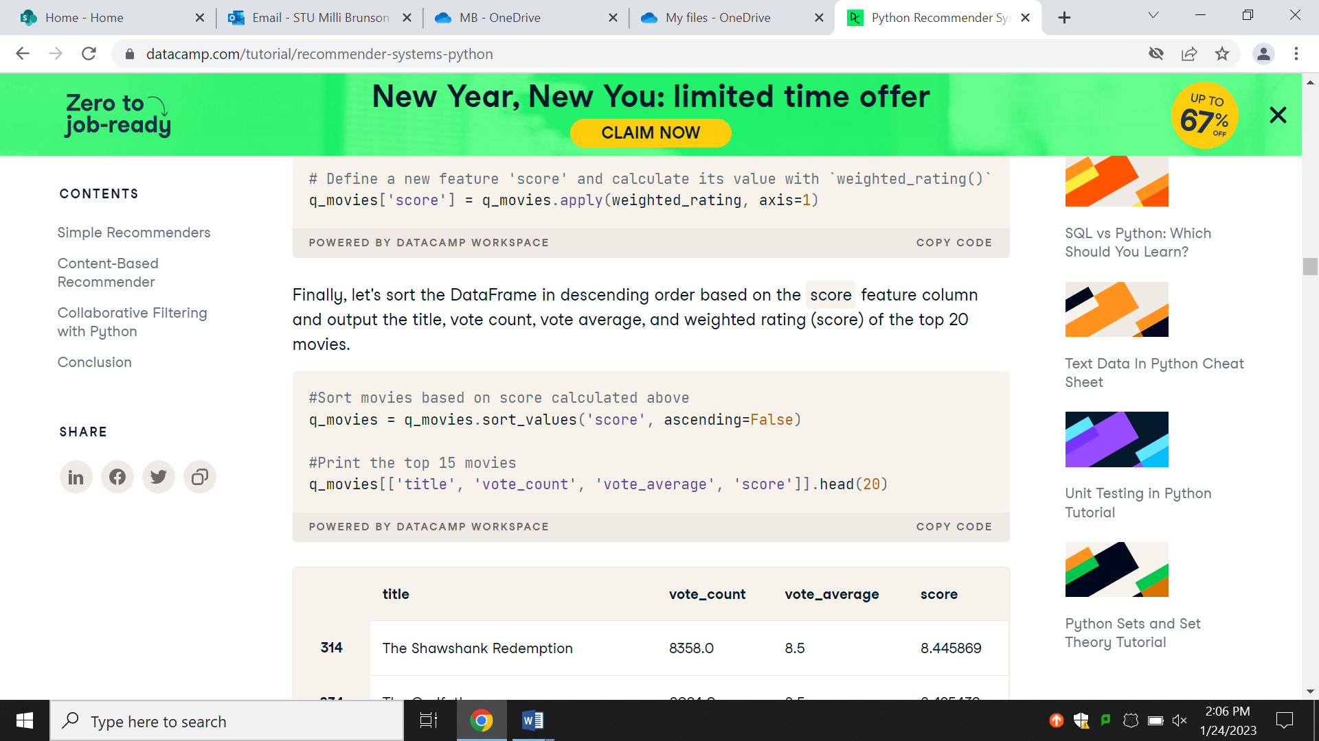

‘sort_values’ sorts the films in order of score

Displays the top 15 films

This recommendation system is more simplistic than item-based recommendation algorithms. However, it provides an outline for my coded solution and suggests which libraries I could use for the maths aspects of my coded solution.

### Graphical user interface

In this area of development, I am using Tkinter to create a graphical user interface in python. This will make it easier to and reduce the time it takes for me to create interactive buttons and search bars.

#### Home screen

|  |  |
| --- | --- |
|  | The home screen will be the first screen that is displayed when the program is run therefore no conditions need to be met for the screen to be displayed. I used paint to create the screen designs and used tkinter to create a home screen window that looked like the design.  I created the home screen window and a procedure to close the home screen window. Since I am using procedures in this area of the program, the home screen procedure must be defined after the recommendation and stock screen procedures as the home screen procedure needs to be able to call the previously defined procedures.  The closehome procedure closes the homescreen window (hwindow). It is called by the recommendation (btn_recs) and stock (btn_stock) buttons when clicked.  I created a procedure called ‘homescreen’ which displays the home screen when called. I used tkinter to make the home screen look like the design and give it interactive buttons. The buttons ‘Stock’ and ‘Recommendations’ call the stockscreen and recscreen procedures respectively and call the closehome procedure.  Completing this part of the code gives me the base of my graphical user interface and allows me to link my recommendations and stock screen to the home screen. |

|  |  |  |  |  |
| --- | --- | --- | --- | --- |
| What is being tested | Input | Justification of input | Expected outcome | Actual outcome |
| Does the home screen load | The program being run | To get to program to run | Home screen is displayed. | Home screen is displayed. |
| Stock button calls the stockscreen procedure | Left mouse click on Stock button | Button must be interacted with for its command to be carried out | stockscreen procedure is called. | stockscreen procedure is called. |
| Stock button calls the closehome procedure | Left mouse click on Stock button | Button must be interacted with for its command to be carried out | closehome procedure is called. | closehome procedure is called. |
| Recommendation button calls the recscreen procedure | Left mouse click on the Recommendations button | Button must be interacted with for its command to be carried out | recscreen procedure is called. | recscreen procedure is called. |
| Recommendation buttons calls the closehome procedure | Left mouse click on the recommendations button | Button must be interacted with for its command to be carried out | closehome procedure called. | closehome procedure is called. |

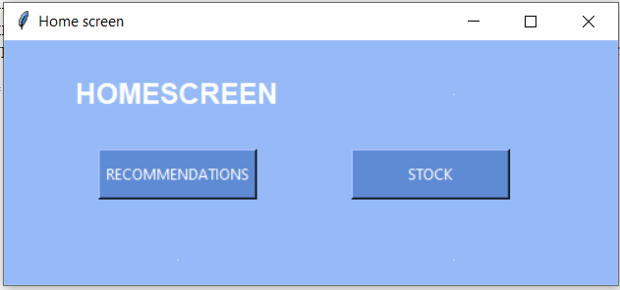Home screen window when the program is run:

These are the requirements being looked at:

|  |  |  |  |  |
| --- | --- | --- | --- | --- |
|  | Requirement | Justification | Reference | Completed |
| 3. | Home screen | This will allow the user to access the recommendation and stock sections. | Updated requirements interview. | Yes |
| 4. | Home screen recommendation and stock options. | This is necessary to allow the user to access the other parts of the program. | Updated requirements interview. | Yes |
| 5. | Buttons to access the recommendation screen | This allows the user to interact with the program and is better than the user typing an answer or pressing a key as there is less room for mistypes. | Initial requirements interview. | Yes |
| 6. | Button to access the stock screen. | This allows the user to interact with the program and is better than the user typing an answer or pressing a key as there is less room for mistypes. | Initial requirements interview. | Yes |
| 7. | Different colours and shades for the background, buttons, search bar and text | This will make it easier for the user to use as it will be more readable and easier to distinguish between background, buttons and the search bars. | Updated requirements interview | Yes |

Me: I have completed all but one of the above requirements. The buttons are functional and when pressed the home screen window closes and the recommendation or stock screen window opens, depending on the button clicked. This allows the user to interact with the program and access the different aspects of it. The background, text, and button are different colours to make it easier for the user to read and distinguish between the different parts.

Katherine Northmore: Good progress has been made and the home screen is functioning as desired apart from the list not being displayed. Now that the home screen is functional, I would like you to make the recommendation and stock screens.

#### Recommendations screen

|  |  |
| --- | --- |
|  | In this part of my code I am creating a procedure for displaying the recommendation screen. This procedure is called when the Recommendations button on the home screen is clicked.  The lists customer_ID and product_ID will get their information from the recommendations algorithm but since that is not completed yet the lists cannot display the data they would display in the final program.  The number of rows created is the number of items in the customer ID list plus 3. This means there is space for the header, search bar and back button, and the column headers, and every item in the customer ID list.  The use of columnconfigure and rowconfigure allows the rows and columns to expand to fill the available space when the window is expanded. The use of frames makes the placement of widgets easier.  The search bar created by ‘search_ent = tk.Entry (…)’ will search the list of customer IDs to find ones that are similar or match the entry. However, since that aspect of the program is not yet complete it does not have a list to search.  When the back button is clicked, the procedure to display the home screen should be displayed. However, since the home screen procedure has been defined after the recommendations procedure, it is not possible to call the procedure as python does not allow for procedures that haven’t been defined yet to be called. This makes the back button non-functional. |

|  |  |  |  |  |
| --- | --- | --- | --- | --- |
|  | Input | Justification of input | Expected outcome | Actual  outcome |
| Is the recommendation screen displayed when the recommendation button is clicked? | Left mouse click on the recommendations button on the home screen | Clicking on the recommendations button will allow for the recommendation screen to be displayed | The recommendations screen is displayed | The recommendations screen is displayed. |
| Is a list of customer IDs displayed | List of customer IDs | List cannot be displayed if the list is empty | The content of the customer_ID list is displayed | The content of the customer_ID list is displayed. |
| Is a list of recommended product IDs displayed | List of product IDs recommended for a customer | List cannot be displayed if the list is empty | The content of the recommended product IDs list is displayed | The content of the recommended product IDs list is displayed. |
| Does text appear in the search bar when it is typed into | Text from the keyboard | If no text has been type then there isn’t anything to display | The text that has been entered appears in the search bar | The text that has been entered appears in the search bar. |
| Does the search bar search the list of customer IDs | List of customer IDs | List cannot be searched if there is no list or the list is empty | List is searched for matching customer IDs | List is not searched |
| Is the home screen displayed when the back button is clicked | Left mouse click on the back button | Clicking on the back button will allow for the home screen to be displayed | Recommendation screen window closes and home screen window opens. | Recommendations screen continues to be displayed, home screen window does not open. |

Recommendations screen window when the recommendations button is pressed

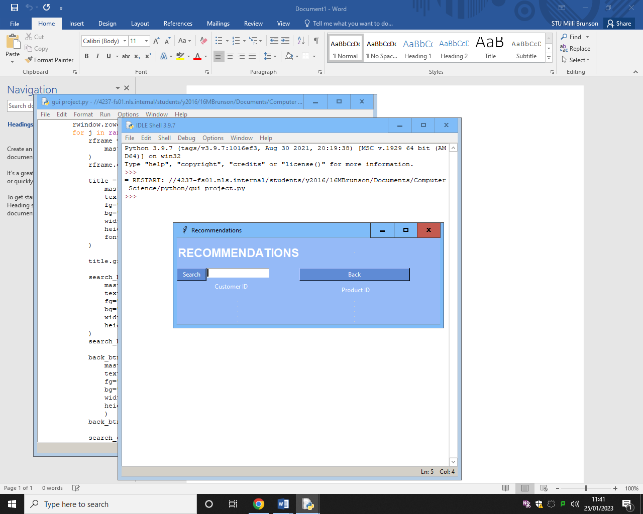

Requirements being looked at:

|  |  |  |  |  |
| --- | --- | --- | --- | --- |
|  | Requirements | Justification | Reference | Completed |
| 7. | Different colours and shades for the background, buttons, search bar and text | This will make it easier for the user to use as it will be more readable and easier to distinguish between background, buttons and the search bars. | Updated requirements interview | Yes |
| 8. | Search bar | This will allow the user to find customers and products quickly | Updated requirements interview | No |
| 9. | Back button to access the home screen from the recommendation screen. | This will allow the user to go back to the home screen and access other sections without having to exit the program. | Proposed solution. | No |
| 12. | Recommendation screen | This will allow the recommendation information to be displayed. | Initial requirements interview. | Yes |
| 13. | List of customers and products they should be recommended | This will allow the user to see which products to recommend to which customers. | Initial requirements interview. | No |

Me: I have successfully completed 2 of the above requirements. The background, buttons, and text are different colours to make it easier for the user to read and us and the recommendation screen is displayed when the recommendation button on the home screen is clicked. The list of customers and what products they should be recommended can’t be implemented yet as the recommendation algorithm is not completed so there is no list to display. The back button does not close the recommendation screen and open the home screen when clicked. This is because I have used procedures to make the screens and in order for the home screen to call the recommendation screen procedure when the recommendations button is clicked, the home screen procedure must be defined after the recommendation screen procedure. However, this means that the home screen procedure can’t be called from the recommendation screen procedure when the back button is clicked.

Katherine Northmore: The back button should be functional otherwise the user will have to close the program and open it again to access different parts. After creating a functional stock screen, I would like you to find a way to get the back button to work. Once the recommendation algorithm is completed the list pf customers and what products they should be recommended should be displayed.

#### Stock screen

|  |  |
| --- | --- |
|  | In this section of my code, I am creating a procedure that displays the stock screen window when called. It is called when the Stock button on the home screen is clicked.  The lists of product IDs and dates will get their information from the stock prediction algorithm. Since this is not complete yet I have created short lists to show that the data from the lists can be displayed in the correct area of the screen. The data in these lists is different to what will be in there when the program is completed.  The number of rows created is equal to the number of products plus 3, this means that there is space for every product ID to have a row while still having space for the 3 rows necessary for the header, the search bar and back button and the column headers.  As I have done in the recommendations screen, I have made use of columnconfigure and rowconfigure to allow the rows and columns to expand to fill the available space when the window is expanded, and frames makes the placement of widgets easier.  The search bar created by ‘search_ent = tk.Entry (…)’ will search the list of product IDs to find ones that are similar or match the entry. However, since that aspect of the program is not yet complete it does not have a list to search.  When the back button is clicked the home screen procedure should be called. However, the home screen procedure is defined after the stock screen procedure and since python does not allow undefined procedures to be called, it cannot be called. Making the back button non-functional. |

|  |  |  |  |  |
| --- | --- | --- | --- | --- |
|  | input | Justification of input | Expected outcome | Actual  outcome |
| Is the stock screen displayed when the stock button is clicked? | Left mouse click on the stock button on the home screen | Clicking on the stock button will allow for the stock screen to be displayed | The stock screen is displayed | The stock screen is displayed |
| Is a list of product IDs displayed | List of product IDs | List cannot be displayed if the list is empty | The content of the product_ID list is displayed | The content of the product_ID list is displayed |
| Is a list of dates displayed | List of dates of when products are expected to run out | List cannot be displayed if the list is empty | The content of the dates list is displayed | The content of the dates list is displayed |
| Does text appear in the search bar when it is typed into | Text from the keyboard | If no text has been type then there isn’t anything to display | The text that has been entered appears in the search | The text that has been entered appears in the search bar |
| Does the search bar search the list of product IDs | List of product IDs | List cannot be searched if there is no list or the list is empty | List is searched for matching product IDs | List is not searched |
| Is the home screen displayed when the back button is clicked | Left mouse click on the back button | Clicking on the back button will allow for the home screen to be displayed | Stock screen window closes, and home screen window opens. | Stock screen continues to be displayed; home screen window does not open |

Stock screen window when the stock button is pressed:

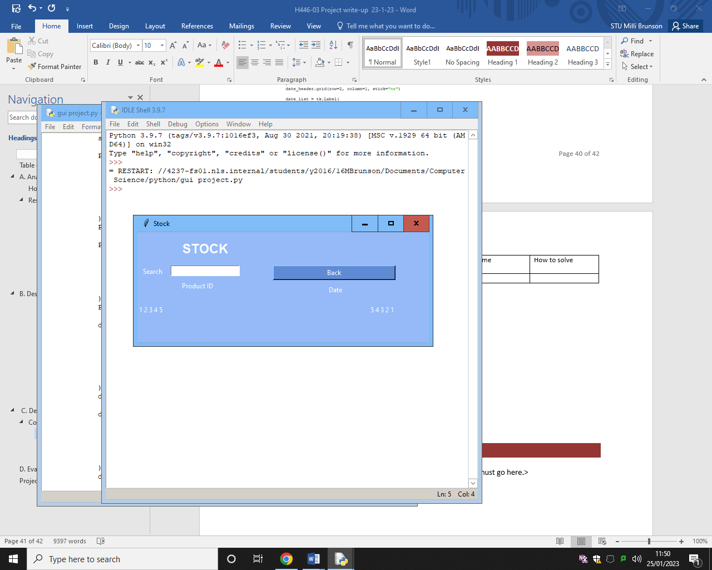

Requirements being tested:

|  |  |  |  |  |
| --- | --- | --- | --- | --- |
|  | Requirement | Justification | Reference | Completed |
| 7. | Different colours and shades for the background, buttons, search bar and text | This will make it easier for the user to use as it will be more readable and easier to distinguish between background, buttons and the search bars. | Updated requirements interview | Yes |
| 8. | Search bar | This will allow the user to find customers and products quickly | Updated requirements interview | No |
| 10. | Back button to access the home screen from the stock screen. | This will allow the user to go back to the home screen and access other sections without having to exit the program. | Proposed solution. | No |
| 14. | Stock screen | This will allow the stock information to be displayed for the user. | Initial requirements interview. | Yes |
| 15. | List of products and the date they will run out | This will allow the user to see when each product will run out. | Initial requirements interview. | No |

Me: I have successfully completed 2 of the above requirements. The background, buttons, and text are different colours to make it easier for the user to read and use and the stock screen is displayed when the stock button on the home screen is clicked. The list of products and when they are predicted to run out can’t be implemented yet as the prediction algorithm is not completed so there is no list to display. The back button does not close the stock screen and open the home screen when clicked. This is because I have used procedures to make the screens and in order for the home screen to call the stock screen procedure when the stock button is clicked, the home screen procedure must be defined after the stock screen procedure. However, this means that the home screen procedure can’t be called from the stock screen procedure when the back button is clicked.

Katherine Northmore: The back button should be functional otherwise the user will have to close the program and open it again to access different parts. Once the prediction algorithm is completed the list of products and when they are predicted to run out should be displayed. Now that all three screens have been created, I want you to make a functional back button.

#### Functional back button for stock and recommendation screen

|  |  |
| --- | --- |
|  | I have created 3 separate executable program files. Recscreen contains the code for the recommendation screen, stockscreen contains the code for the stock screen and homescreen contains the code for the home screen. Before defining the home screen procedure in the home screen file, I have imported the recscreen and stockscreen files, they will be loaded when the recscreen and stockscreen procedures are called respectively.  In the recscreen file I have imported the home screen file and in the stockscreen file I have imported the home screen file. This allows me to solve the problem of an incorrectly functioning back button. Previously, the back button would not work because it called the home screen procedure from the recommendation screen and stock screen procedures, this did not work as the home screen procedure was defined after the recommendations and stock screen procedures. Importing code from separate files allows me to get around this problem.  I have created the procedures closestock and closerec to close the stock and recommendations window when the back button is clicked. |

|  |  |  |  |  |
| --- | --- | --- | --- | --- |
|  | Input | Justification of input | Expected outcome | Actual outcome |
| Home screen displayed when back button on recommendation screen is clicked | Left mouse click on back button on the recommendation screen | Clicking on the back button will allow for the home screen to be displayed | Recommendation screen window close and home screen window opens. | Recommendation screen window close and home screen window opens. |
| Home screen displayed when back button on stock screen is clicked | Left mouse click on back button on stock screen | Clicking on the back button will allow for the home screen to be displayed | Stock screen window closes and home screen window opens | Stock screen window closes and home screen window opens |

Requirements being looked at:

|  |  |  |  |  |
| --- | --- | --- | --- | --- |
|  | Requirement | Justification | Reference | Completed |
| 10. | Back button to access the home screen from the stock screen. | This will allow the user to go back to the home screen and access other sections without having to exit the program. | Proposed solution. | Yes |

Me: I have created a functioning back button. When it is clicked from the recommendation screen or stock, the recommendation or stock screen window closes and the home screen window opens.

Katherine Northmore: It is good that the back button is functioning correct. This means that the program does not need to be closed and then opened again to access the other parts of it. Now that the back button, is functional I would like you to make a working search bar.

#### Displaying the recommendations on the recommendations screen

Now that I have finished the recommendation algorithm, I can work on displaying the list of customer IDs and product IDs correctly. Originally, I had each item in each list in a different frame but I have decided to change this so I can make use of Tkinter “Listbox” widget.



Creates a vertical scroll bar that can be used with the Listbox widget.

Insets the scroll bar into the right side of the 4th row and 1st column.

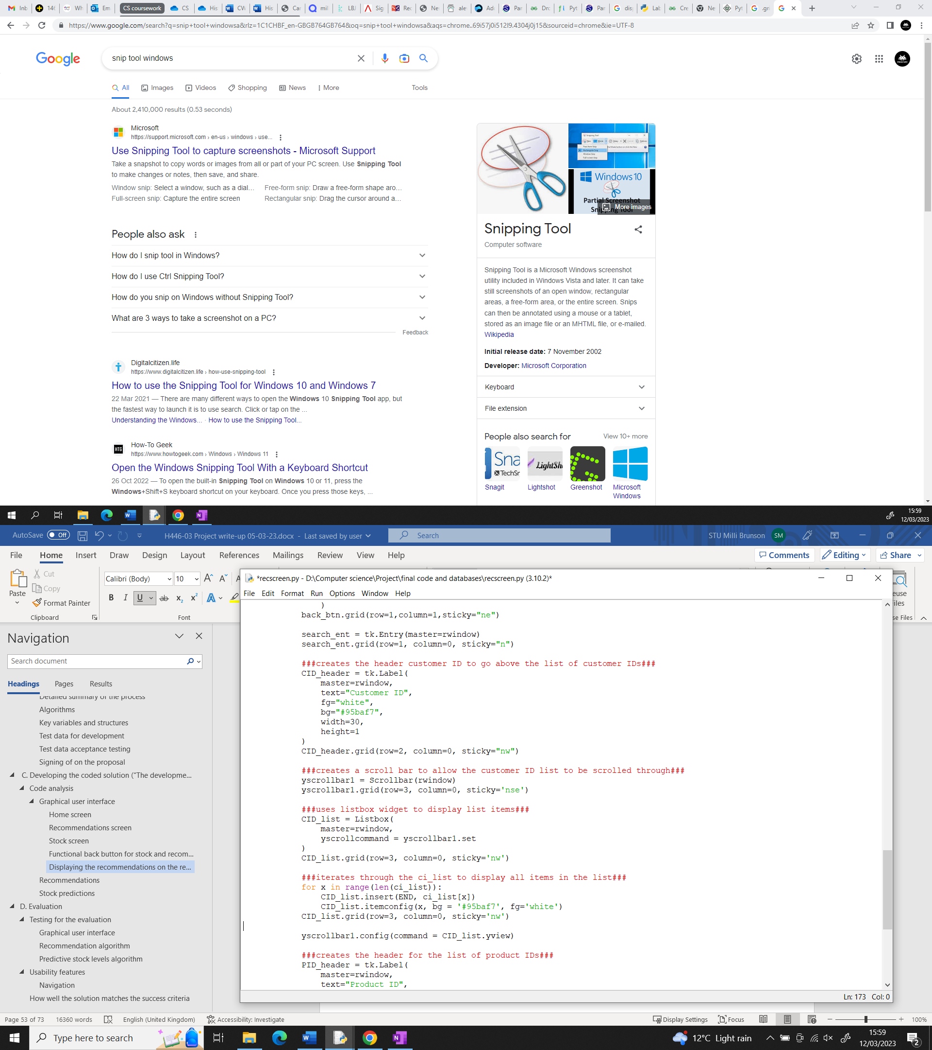

Links the listbox to the vertical scroll bar.

Creates a listbox to displays the items of the ci_list.

Places the listbox in the 4th row of the 1st column on the top left.

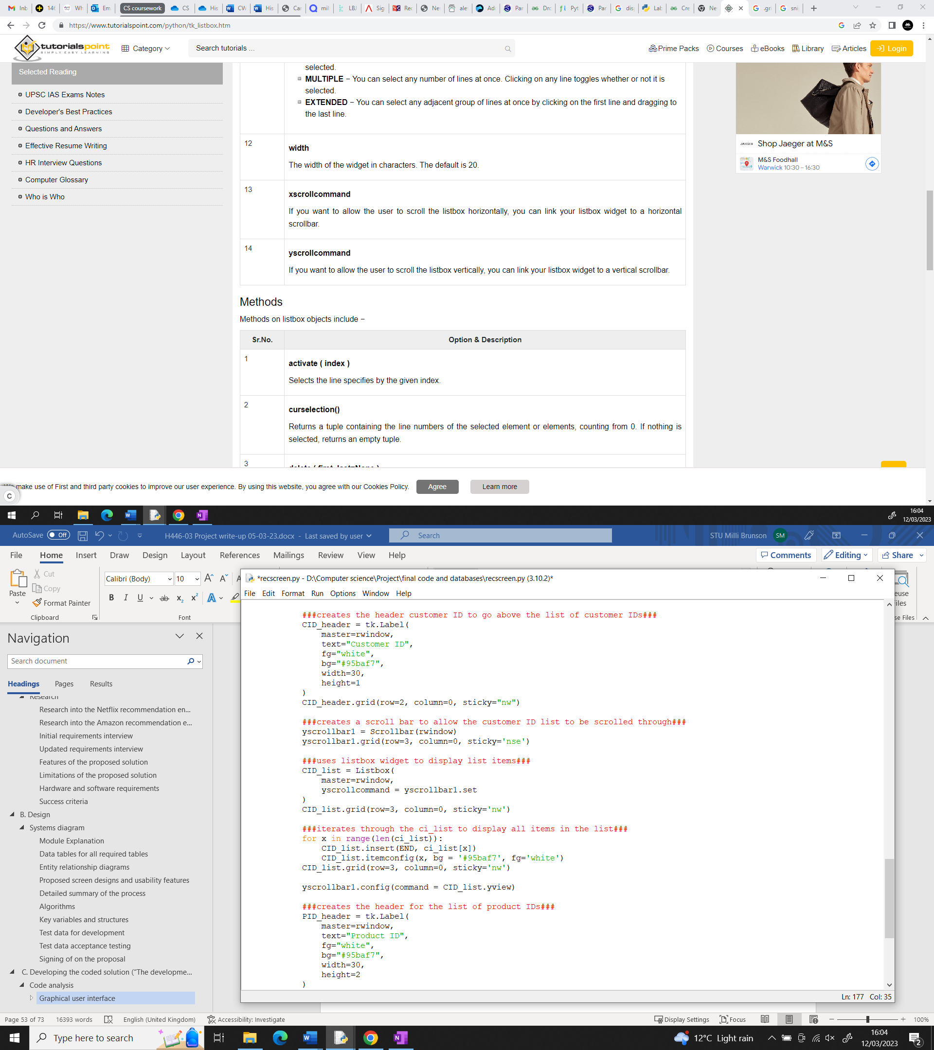

Iterates for every item in the ci_list.

Configures the properties of the CID_list listbox.

Inserts the item being looked at into the CID_list listbox.

Attached the scroll bar to the CID listbox.

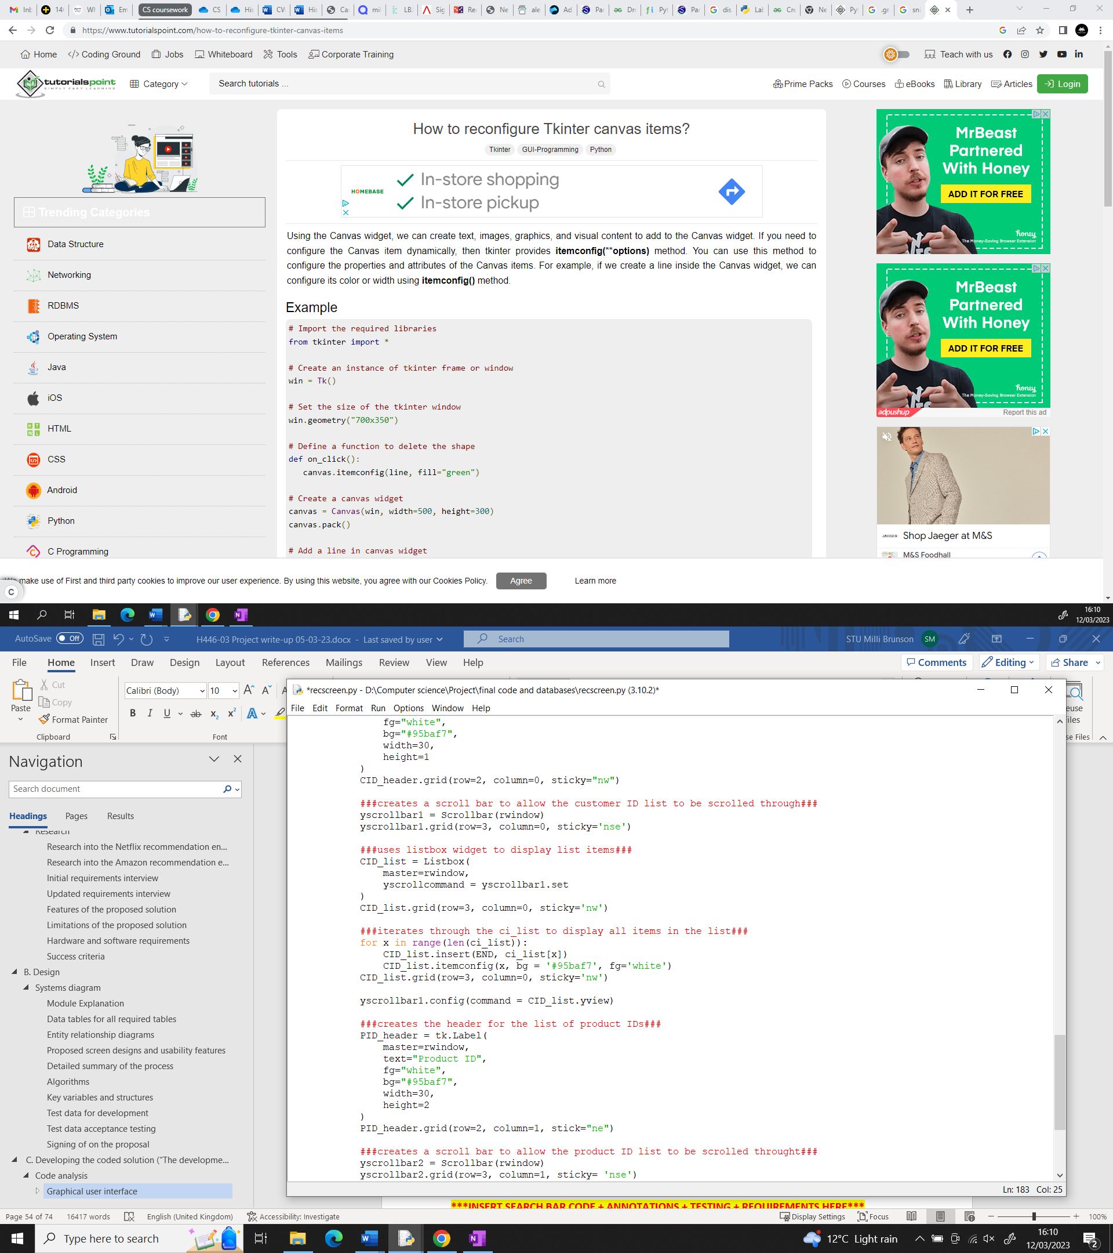

I have repeated this for displaying the product ID list only changing the grid placement, variable names and which list is being used.

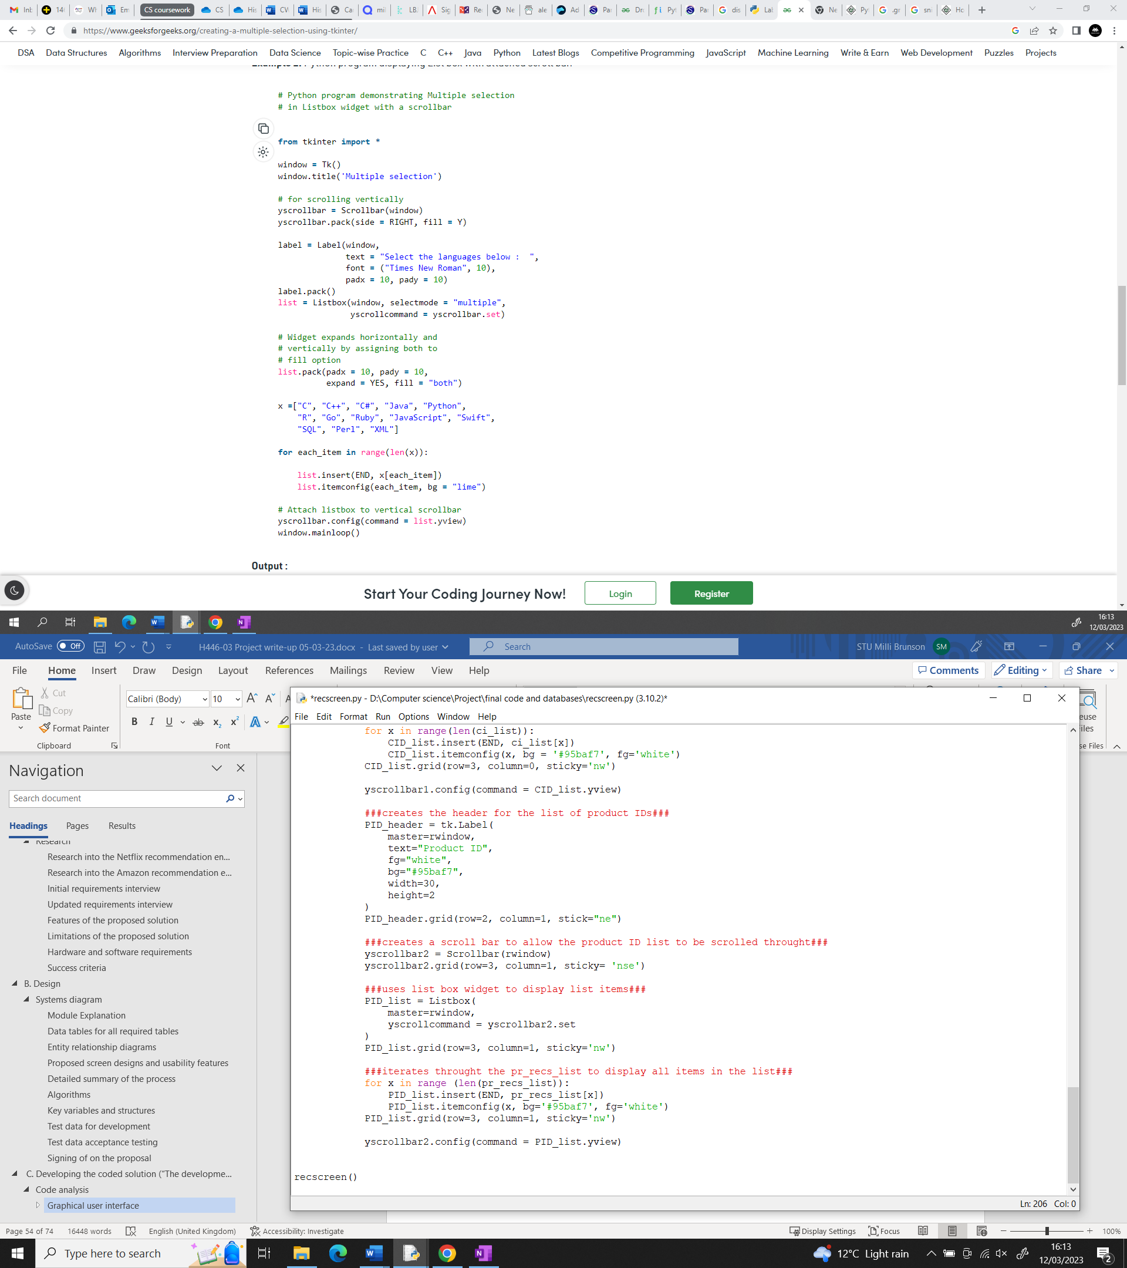

Recommendation screen when recommendation button on home screen I clicked:

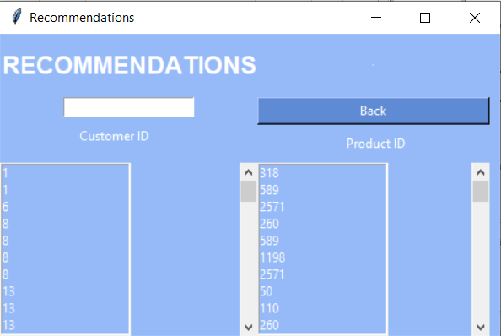

|  |  |  |  |  |
| --- | --- | --- | --- | --- |
|  | input | Justification of input | Expected outcome | Actual  outcome |
| Is the list of customer ID’s displayed? | Customer ID list | If there is no data to display, nothing will be displayed | Customer ID list is displayed with each customer ID on a different line | Customer ID list is displayed with each customer ID on a different line. |
| Is the list of recommended product displayed? | Recommended products list | If there is no data to display, nothing can be displayed | Recommended products list is displayed with each product ID on a different line. | Recommended products list is displayed with each product ID on a different line. |

Requirement being looked at:

|  |  |  |  |  |
| --- | --- | --- | --- | --- |
|  | Requirement | Justification | Reference | Completed |
| 13. | List of customers and products they should be recommended | This will allow the user to see which products to recommend to which customers. | Initial requirements interview. | Yes |

#### Displaying the stock data on the stock screen

Now that I have finished the code for estimating when each product will go out of stock, I can display this data on the stock screen.

Creates a scroll bar to allow the product ID list to be scrolled through.



Uses the listbox to display the product ID list

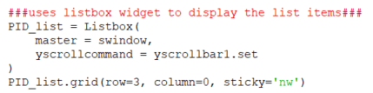

Links the listbox to the vertical scroll bar

Iterates through for every item in the list.

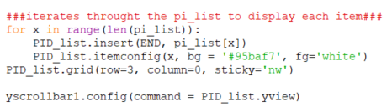

Attaches the scroll bar to the listbox.

Configures the list box properties.

Inserts the item being looked at into the list box.



I did the same to display the dates.

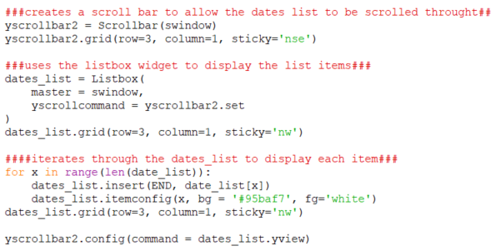

Stock screen:

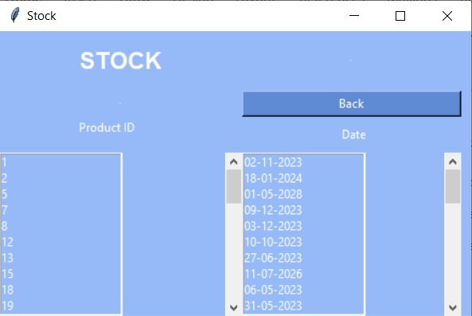

|  |  |  |  |  |
| --- | --- | --- | --- | --- |
|  | input | Justification of input | Expected outcome | Actual  outcome |
| Is the list of product IDs displayed? | List of products | If there is no data to display, nothing can be displayed. | List of product IDs is displayed with each product ID on a different line. | List of product IDs is displayed with each product ID on a different line. |
| Is the list of predicted out of stock dates displayed? | List of predicted out of stock dates | If there is no data to displayed, nothing can be displayed. | List of predicted out of stock dates is displayed with each date on a different line. | List of predicted out of stock dates is displayed with each date on a different line. |

Requirement being looked at:

|  |  |  |  |  |
| --- | --- | --- | --- | --- |
|  | Requirement | Justification | Reference | Completed |
| 15. | List of products and the date they will run out | This will allow the user to see when each product will run out. | Initial requirements interview. | Yes |

Me: The recommendations information is now displaying correctly on the recommendation screen and there is a scroll bar so all the data can be viewed. The stock information is also being displayed correctly on the stock screen and there is also a scroll wheel.  
Katherine Northmore: This is good. The only thing left is the working search bar so I’d like you to focus on that next to finish the program.

#### Functional search bar

Now that I all the data is displaying correctly, I can work on creating a functional search bar so the user can search by customer ID and see all matching customer IDs and the products they should be recommended and search by product ID to see the date that product will run out on.

After doing some research on creating search bars in tkinter, it does not appear that a search bar can be created that has the functionality I want it to have. Search bars can be created using the Listbox widget and it is possible to only display text that matches what is in the search box in the list box. However, because I have used two separate list box to display the data since it is not possible to display 2-D arrays using the listbox function, it is not possible to display the recommendations for the customer ID being searched for or to display the date for the product ID being searched for. Because of this I will remove the entry bar and search button from the code since they will have no functionality and may make the program confusing to use if left in.

Recommendation screen:

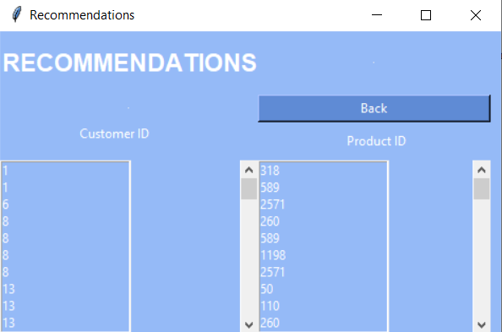

Stock screen:

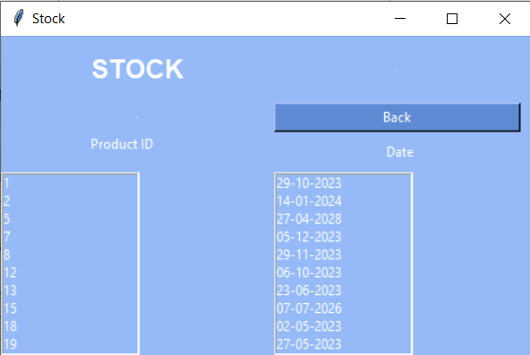

|  |  |  |  |  |
| --- | --- | --- | --- | --- |
|  | input | Justification of input | Expected outcome | Actual  outcome |
| Is the customer ID list searched to finding similar or matching customer IDs? | Customer ID entered into the entry bar. | List of customer IDs can’t be searched unless what is being searched for is known. | Customer ID list is searched for items that contain the characters entered in the order they were entered. | Search does not happen. |
| Does the search bar display the list of customer IDs that match the input and the products they should be recommended. | The matching or similar customer IDs | Customer IDs and their recommended products can’t be displayed if they aren’t known. | Matching or similar customer IDs are displayed along with the products they should be recommended. | Matching or similar customer IDs and the products they should be recommended are not displayed. |
| Is the product ID list searched to finding similar or matching customer IDs? | Product ID entered into the entry bar. | List of product IDs can’t be searched unless what is being searched for is known. | Product ID list is searched for items that contain the characters entered in the order they were entered. | Search does not happen. |
| Does the search bar display the list of product IDs that match the input and the date they will run out? | The matching or similar product IDs | Product IDs and the date they will run out on can’t be displayed if they aren’t known. | Matching or similar product IDs are displayed along with the date they are predicted to go out of stock. | Matching or similar product IDs and the dates they are predicted to run out on are not displayed. |

Requirement being looked at:

|  |  |  |  |  |
| --- | --- | --- | --- | --- |
|  | Requirement | Justification | Reference | Completed |
| 8. | Search bar | This will allow the user to find customers and products quickly | Updated requirements interview | No |

Me: it is not possible to give the search bar the functionality we wanted due to limitations of the listbox widget in Tkinter. It’s possible to search the individual boxes however, it does not appear to be possible to display the correct information in both boxes. For example, if you searched by customer ID then it is possible to display only the similar or matching customer IDs in the customer ID box but what is displayed in the recommendations box will not be affected so you will not see the items those customers should be recommended.  
Katherine Northmore: This is a little disappointing as the search bar would have made it easier to find information but you have still coded everything else we discussed for the program. Instead of trying to find a work around I think you should finish coding here as the search bar is useful but not a key part of the program.

### Recommendations

In this area of development, I am creating the recommendation algorithm. I am using the python library pandas to make data manipulation easier and the python library sklearn to make it easier to perform cosine similarity calculations on the data. I will also be using the operator library to make comparing items and carrying out mathematical and logical operations easier.

The csv file stored at that listed location is assigned to the constant ‘rcdpq’.

Uses the pandas library to read the csv file.





Removes all products from grouped_rcdpq that have less than 10 ratings. Cosine similarity is good for spares data sets but there still needs to be a certain amount of ratings for accurate recommendations.

Groups the content of rcdpq by product IDs and determines how many ratings each product has.

Combines grouped_rcdpq_10 and rcdpq to create one data frame that only contains the information about the products with 10 or more ratings.

The cosine_similarity function does not take missing values so fillna. (0) is used to replace missing values with 0s.

Creates a data frame from rcdpq_10 that uses product IDs as an index, has one column for each customer ID and has each customer’s rating for each product. If the customer has not rated a product the rating is recorded as NaN (Not a Number)



|  |  |  |
| --- | --- | --- |
| Product ID | Product 1 | Product 2 |
| Product 1 | 1.00 | 0.23 |
| Product 2 | 0.23 | 1.00 |

|  |  |  |
| --- | --- | --- |
| Product ID (index) | Customer 1 | Customer 2 |
| 1 | 5.0 | 3.5 |
| 2 | 4.5 | NaN |
| 3 | NaN | 4.0 |
| 4 | NaN | 2.0 |
| 5 | 3.0 | NaN |
| 6 | 2.5 | NaN |
| 7 | 4.5 | 5.0 |

Cosine similarity is used to measure how similar the products are. Numbers close to negative 1 indicate that two products are very different. Numbers close to positive 1 indicate that two products are very similar.

Creates a data frame called customer_bought that contains all of the products a customer has bought and the normalised rating information.

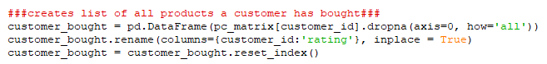

Removes all products the customer has not bought from the customer_bought data frame.

Resets the index so the first row has an index of 0, second has an index of 1 and so on.

Renames the column that previously held the customer ID to rating.

Creates a data frame called customer_nb that contains all of the products. If a customer hasn’t bought a product then the value True is put in the row of that product ID, if the customer has bought that product False is put in the row of that product ID

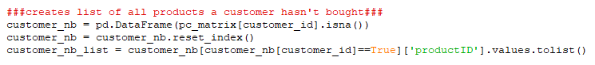

All products where the product ID is true in the customer_nb data frame are added to the list customer_nb_list. This list contains all of the products the customer hasn’t bought.

Cosine similarity measures how similar or different two data points are. It is the cosine of the angle between two vectors which in this case are the data points. The bigger the angle the less similar the two data points are and the smaller the angle the more similar to data points are.

Removes all duplicate customer IDs so there is only one of every customer ID in the list. It creates a dictionary based on the list and then turns that dictionary back into a list. Since dictionary can’t contain repeated values the list now doesn’t contain any repeated customer IDs.

Adds every item in the customerID column to a list called customer_id_list

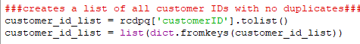

Creates a list called p10_list that contains every item in the productID column of the rcdpq_10 data frame. This list will only contain items with 10 or more ratings.



Removes all duplicate items from the list. Now p10_list only contains one instance of every product ID that has more than 10 ratings.

This creates a loop that the recommendation algorithm itself will be in. The loop will be repeated until it has been repeated the same number of times as there are items in the customer_id_list. This means that recommendations will be generated for every customer in the list.

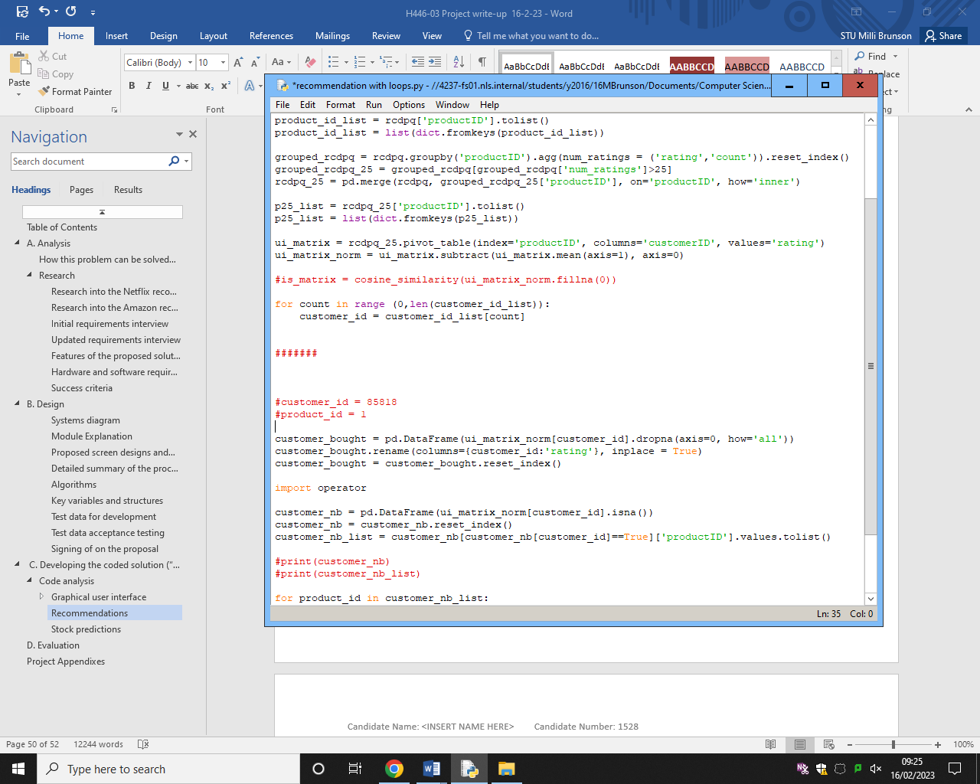

This sets the customer_id that will be used in the calculations to the item in the list that has the same index as the count.

Creates a data frame containing every item the customer has bought.

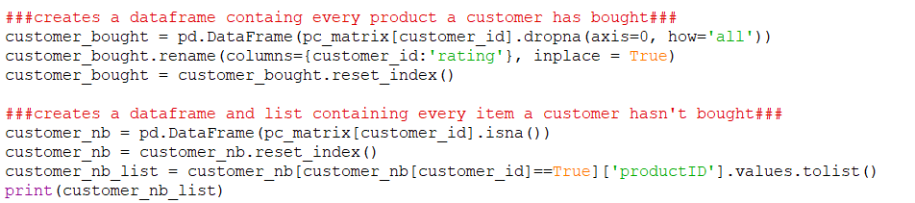

Creates a list of every item the customer has not bought by adding every item in the customer_nb data frame to a list.

This should display every item every customer has not bought. This will allow me to check that the loops are functioning correctly.

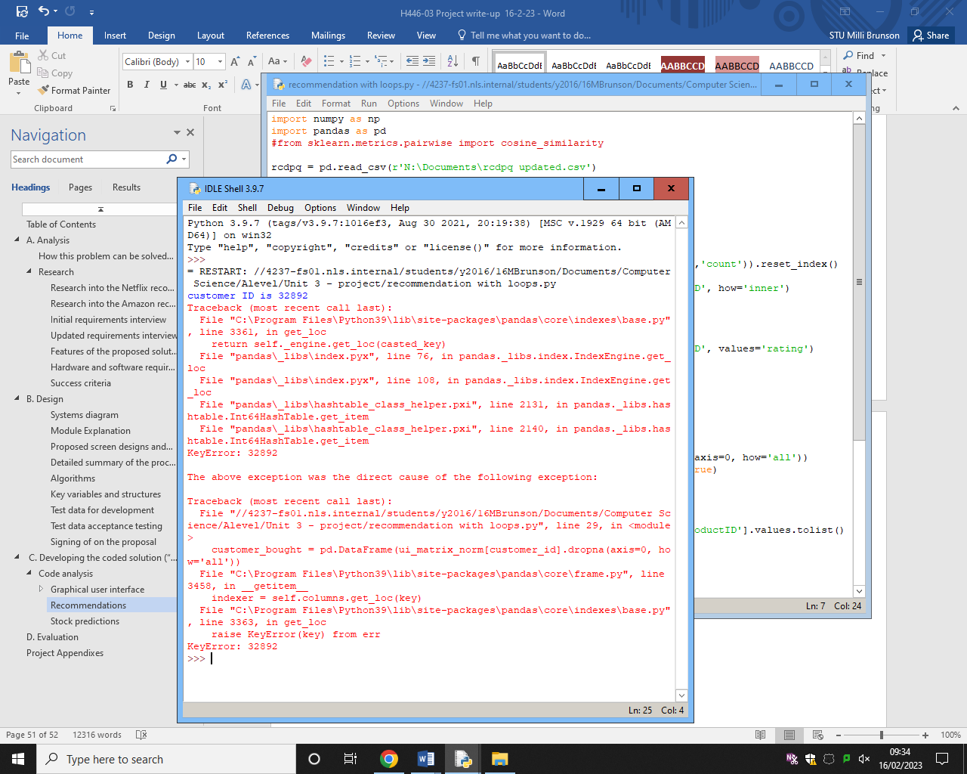

When I run this code to check that the loops are functioning correctly, I get this error. From this error I can see that the part of the loop assigns items in the list to the variable customer_id is working as the first customer ID in the list has been displayed. Key Error tells me that the customer ID does not exist in the ui_matrix_norm data frame and so the products the user has and has not bought can’t be found.

This error has occurred because the pc_matrix_norm data frame only contains information about the products with 10 or more ratings. This means that if a customer has not bought one of those products, they will not exist in the data frame. To solve this, I must change the customer_id_list list to only include the customer IDs of customers who have bought a product with 10 or more ratings. To do this I create the customer_id_list list by adding customer IDs from the rcdpq_10 data frame rather than the rcdpq data frame as the rcdpq_10 data frame only contains customer IDs from the customers who have bought items with 10 or more ratings.

Now the only customer IDs added to the customer ID lists are from the rcdpq_10 data frame. This should prevent the error from occurring.



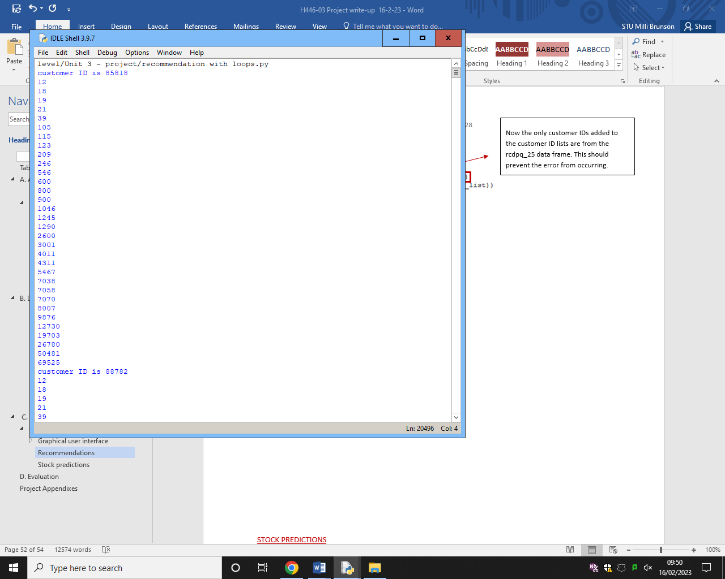

Every item in the customer_nb_list list. The second list is cut off. The list is different for each customer which tells me that the loop is functioning as it should and that it isn’t displaying the same list for each customer but rather it is displaying the items that customer has not bought. This also shows that the code for the customer_nb_list is functioning correctly.

First and second customer IDs in the customer_id_list list. (The customer IDs at index 0 and index 1)

This is the first part of the output when the run the updated code. It prints the customer ID followed by every product ID of the products that customer has not bought. Every customer in the list customer_id_list is displayed along with every item in the customer_nb_list list for that customer. I have only included a section of the output as there are many items in the customer_id_list list so the output is too long to put into this document. This shows that the updated code is working and that the loops are now working as they should.

Now that I know that the loops are functioning correctly, I can remove print (customer_id) and print (product_id) from the code.

Rcdpq 25 table.  
This table will contain information about every purchase made where a product with 25 or more ratings was purchased.

|  |  |  |  |  |
| --- | --- | --- | --- | --- |
| Customer ID | Product ID | Rating | Date purchased | Quantity purchased |
| C | 1 | 5 | 13/02/2022 | 1 |
| D | 4 | 2 | 12/03/2022 | 1 |
| E | 3 | 3 | 23/03/2022 | 1 |



Creates data frame called product_similarity which contains the information from pc_matrix where the column header is the same as the product ID being looked at

Loops for every product a customer hasn’t bought.

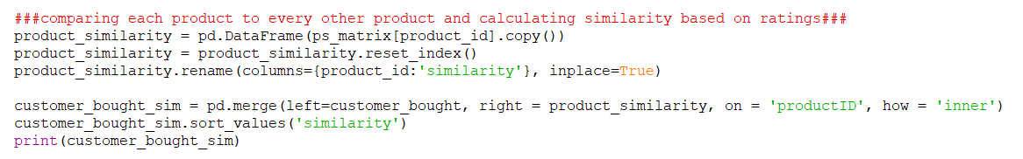

Creates a data frame containing information about how similar the products the customer has bought, and the product currently being looked at.

Displays the customer_bought_sim data frame so I can check that it is working as expected.

Sorts the data based on the value in the similarity column. It is sorted in descending order, so the most similar product is at the top.

When I run this code, it returns this error:

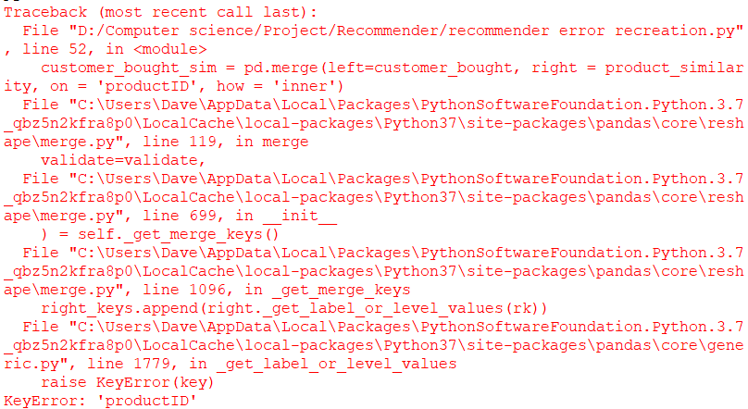

The key error tells me that the program is attempting to access something that does not exist, in this case it is the productID column that does not exist. To find why this is causing an error I have displayed the product_similarity and customer_bought data frames.

Customer_bought data frame output:  
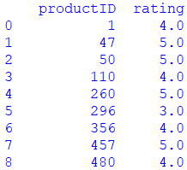

This shows me that the customer_bought data frame is not the cause of the error as it contains a column called productID.

Product_similarity data frame output:  
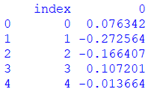

This shows me the product_similarity data frame is the cause of the error as it doesn’t contain a column called productID so there is nothing for the data frames to be joined on. This means that the error is caused by the line of code:  
 

To fix this error I have renamed the column from 0 to productID.



After this change I am still getting this error.  
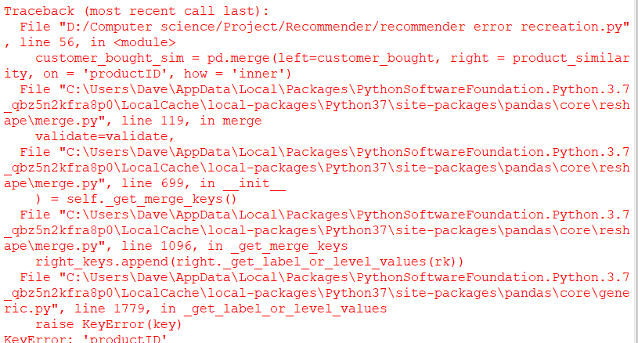

I have changed to type of correlation from cosine similarity to Pearson similarity.



After this change I am no longer getting the error and the product_similarity data frame now has a column with the heading productID.  
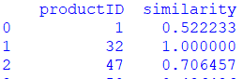

I am unsure why the change in method for finding correlation has worked but when using Pearson correlation the product_similarity data frame contains the productID heading that is required for joining the product_similarity and customer_bought data frames.

Output when printing the customer_bought_sim data frame:

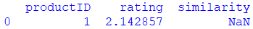

Pearson correlation requires 25 ratings to product accurate results so I have changed these section of code to reflect this.

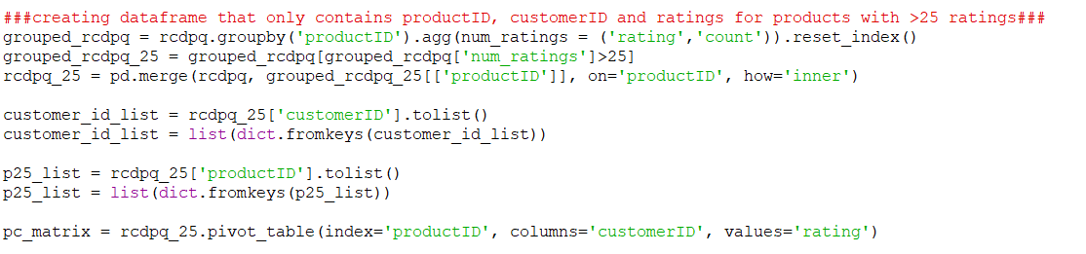

I have also removed the line that normalises the product similarity matrix (ps_matrix) as normalised data is not requried when using Pearson correlation.

This is a section of the full output as the full output is too long to include in the documentation. The similarity score of this product is NaN (Not a Number), this is because no correlation has been found. The lack of correlation is due to the test data I am using contains randomised ratings meaning there is very little correlation. To ensure that correlations are being found and that this is not the code working incorrectly I have used MovieLens Latest Datasets ml-latest-small.zip from <https://grouplens.org/datasets/movielens/> which contains user IDs, film IDs and the customer rating. To prevent having to change the code I have changed userID to customerID and movieID to productID in the data. Since the ratings are not randomly generated there are fewer NaN results.

Output:

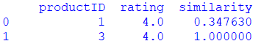

This output shows that the code is working as expected and correlations are being found.



Uses numPy to find the weighted average of how similar products are and the rating from the customer being looked at.

Products that are more similar are weighted more.



Appends the customer ID to the customerID column, the product ID to the productID column and the predicted rating to the predicted rating column of the recommendations data frame.

Creates an empty data frame with the columns customerID, productID and predicted rating to store the predicted ratings of each customer for each product they have not bought. This line of code goes at the top of the program so that items can be appended as the program loops through each customer.



To ensure the code is working correctly after the loop if finished the recommendations data frame will be displayed.  
Output:  
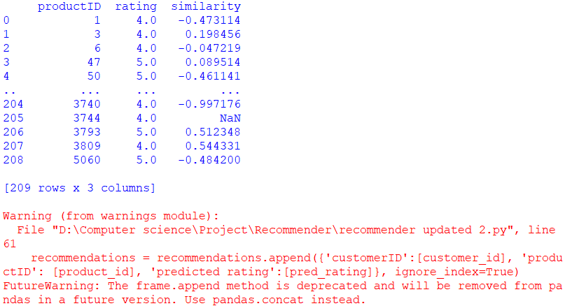

This shows me that the append command is going to be removed from the pandas library soon. To ensure that the code will be functional after this change is made I used pandas.concat instead.



Creates a new row containing the customer ID, product ID and predicted rating and shows which column they go in.

Uses the pandas.concat command to add the new row onto the end of the recommendations data frame.

Output:  
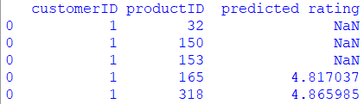

Removes records where the value in the predicted ratings column is less than 3.5



Output when recommendation is printed:  
  
This is not the output I want. To find what the problem is I have created a data frame that only contains records where the value in the predicted rating column is less than 3.5.



Output when recommendations_filtered is printed:  
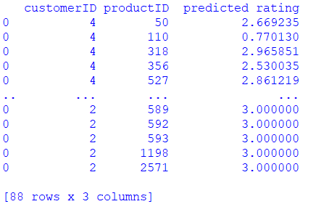  
This output shows me that there is no problem finding records with a predicted rating of less than 3.5. Knowing this I will try to create a data frame without records with a predicted rating of less than 3.5 using the filter pandas command rather than the drop pandas command.

Creates a data frame called recommendations_filtered that only contains records where the value in the predicted ratings column is less than 3.5



Created a data frame called recommendations that contains all of the records for the previous recommendations data frame where the predicted rating is greater than 3.5

Output when recommendations is printed:

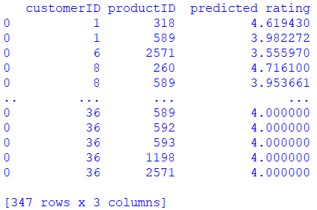

This output only contains records where the predicted rating is greater than 3.5. This shows that using the filter command has been successful.



Creates empty list called ci_list to store all of the customer IDs

Adds every item in the column to the end of the ci_list.

Adds every item in the customerID column to the list ci_list

Output when ci_list is printed:  
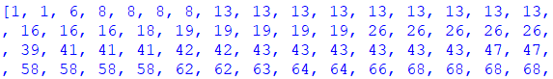

This is only a section of the output, but it shows that every item in the customerID column has successfully been added to the ci_list.



Creates empty list called pr_recs_list to store all of the product IDs

Adds every item in the column to the end of the pr_recs_list.

Adds every item in the productID column to the list pr_recs_list.

Output when pr_recs_list is printed:

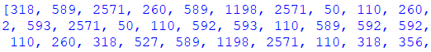

This is also only a section of the output, but it shows that every item in the productID column has been successfully added to the pr_recs_list.

|  |  |  |  |  |
| --- | --- | --- | --- | --- |
|  | input | Justification of input | Expected outcome | Actual  outcome |
| Is the CSV file read? | CVS files location on the computer. | Can’t read the CSV file is its location isn’t known. | CSV file and all of its data is read correctly. | CSV file and all of its data is read correctly. |
| Is a recommendations data frame created to store the results? | Column headers and data frame name. | Data frame name is required to create the data frame. Column headers necessary to insert the data into the correct columns later. | Data frame with the columns customer ID, product ID and predicted rating is created. | Data frame with the columns customer ID, product ID and predicted rating is created. |
| Is how similar products are found using cosine similarity? | Product IDs and ratings data. | Cosine similarity can’t be found if the is no data to compare. | Cosine similarity is used to find how similar each product is to every other product. | Pearson correlation is used to find how similar each product is to every other product. |
| Is a list of products a customer has bought created? | Customer and order data. | Needs access to purchase histories to create a list of all products bought by a customer. | List of every product a customer has bought is created. | Data frame containing all the products a customer has bought, a list was not necessary. |
| Is a list of products a customer hasn’t bought created? | Customer, product and order data | Needs access to purchase histories and customer and product data to create a list of everything a customer hasn’t bought. | List of every product a customer hasn’t bought. | List of every product a customer hasn’t bought. |
| Does it loop for every customer? | List of every customer. | Can’t loop for however many customers there are if the number of customers is unknown. | Loops for every customer. | Loops for every customer. |
| Does it loop for every product that a customer hasn’t bought? | List of products a customer hasn’t bought. | Can’t loop for however many products the customer hasn’t bought is the number of products is unknown. | Loops for every product a customer hasn’t bought. | Loops for every product a customer hasn’t bought. |
| Does it predict the rating a customer will give each product | Customer, product and rating data | Can’t make predictions without data to base those predictions on. | Predicts each customers rating for each product. | Predicts each customers rating for each product. |
| Does it store the products a customer should be recommended? | Customer ID, product ID, predicted rating. | Needs data to store. | The customer ID, product ID and predicted ratings are stored. | The customer ID, product ID and predicted ratings are stored in a data frame. |
| Is a list of customers created? | Customer IDs | List needs data to store. | List of customer IDs created using the recommendations data frame. | List of customer IDs created using the recommendations data frame. |
| Is a list of the recommended products created? | Product IDs | List needs data to store. | List of product IDs created using the recommendations data frame. | List of product IDs created using the recommendations data frame. |

Requirements being looked at:

|  |  |  |  |  |
| --- | --- | --- | --- | --- |
|  | Requirement | Justification | Reference | Completed |
| 1. | Item-based collaborative filtering | This will find recommendation with limited customer data. | Amazon recommendation engine. | Yes |
| 2. | Cosine similarity | This will find how similar products are allowing for recommendations to be made | Features of the proposed solution. | No |

Me: I have finished the recommendation algorithm. Customer purchase history is considered, products a customer has already bought are not considered for recommendation. However, what is considered when making recommendations is limited because it is an item-based recommender meaning the only thing considered is the rating not price or theme of the product. But it doesn’t need to consider these things to make rating predictions. It looks at how similar products are based on the ratings they have been given and using this to predict the users rating. No customer information is considered so there are no safety or security concerns.   
Katherine Northmore: You have made good progress; the recommendation algorithm is one of the main parts of the program. Now I would like you to work on the stock estimation algorithm, this way you can update the user interface in one go.

### Stock predictions

In this area of development, I will be creating the stock prediction algorithm, I will use the python library datetime to get the current date and the date 30 days ago and the python library pandas to make working with csv files easier.

Importing the necessary libraries for this section of the code.

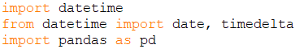

Using the pandas library to read the csv file rcdpq.



Items in the date column are read as dates rather than integers or stings.

When I run this code, I get this error:

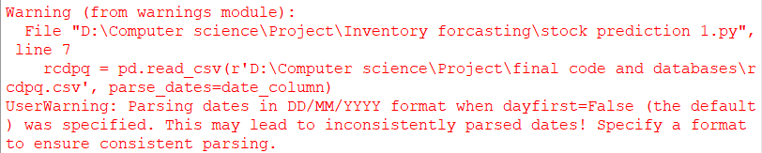

I get his error because I have not specified what format the dates in the rcdpq file. To resolve this error I specified that in the rcdpq csv file the dates are formatted with the day first.



The current date is assigns to the variable ‘end_date’ to allow rows to be filtered.



Uses the datetime library to find the date 30 days before the current date.

Since the data I am using is old, I will assign a different start and end date so that the algorithm has data to work with.

Uses pandas.Series.between() toselects the rows between the start and end date. .loc is used to extract these rows.

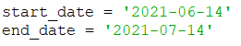



Adds every item in the productID column to a list called product_list.

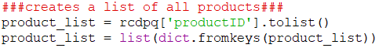

Creates a list of product IDs that does not contain any duplicates by converting the product_list to a dictionary which can’t contain duplicates and then back to a list.

Creates a data frame called stock_level_predictions with two columns, productID and outofstockdate to store the results.



Loops for every product ID in the product list

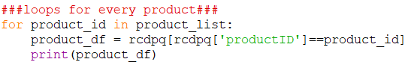

Creates a data frame that only contains items in the rcdpq data frame where the product ID is the same as the one currently being looked at.

Extracts the rows where the date it between the start and end date.



Output when product ID is 1:  
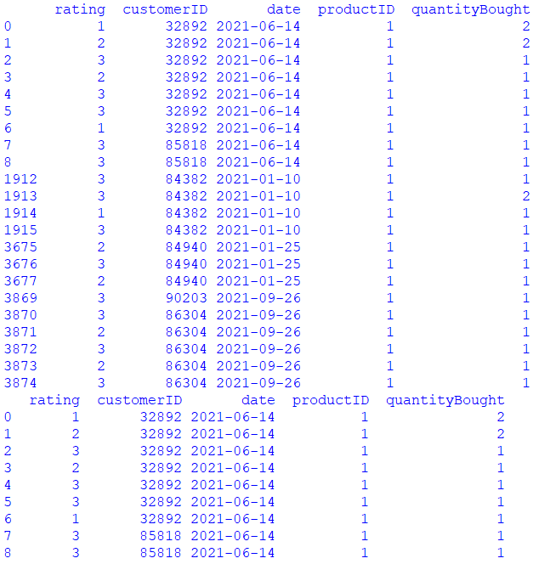

Adds every item in the quantity Bought column of the thirty days data frame to a list.

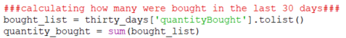

Only calculates the estimated number of days if any products have been sold to prevent an error if when it tries to divide 0 by 30.

Adds up every number in the list to find how many were bought in the past 30 days.

Finds how many are sold per day in the last 30 days on average.

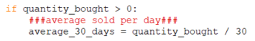

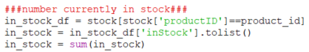

Reads the stock csv file to find how many of the product are currently in stock as stores the value as an integer.

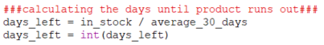

Uses the datetime library to calculate the date the product will go out of stock on.

Uses how many of the product are bought per day to calculate how many days until the product goes out of stock.



Creates a new row containing the product ID and out of stock date.

Stores the date in day-month-year format.

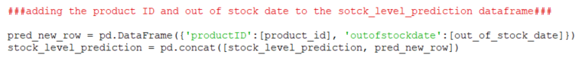

Adds the new row to the stock_level_prediciton data frame.

Adds every item in the stock_level_prediction column to the list.

Adds every item in the productID column to the list.

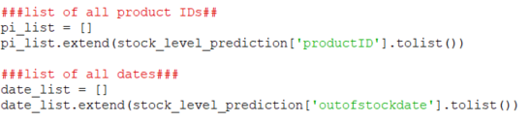

|  |  |  |  |  |
| --- | --- | --- | --- | --- |
|  | Input | Justification of input | Expected outcome | Actual outcome |
| Are the CSV files read correctly? | CSV files contain product, customer, and stock levels information. | This is the information the program needs to make estimations. | CSV files are read correctly, dates are read as dates. | CSV files are read correctly, dates are read as dates. |
| Is current date accessed? | Current date. | Program needs the current date to make predictions based off the current date. | Current date is correct. | Current date is correct. |
| Is a data frame created to store the results? | Data frame name and column headings. | Column headings will make it easier to add data, name is required to reference it. | An empty data frame with two columns is created. | An empty data frame is created with two columns, product ID and out of stock date. |
| Does it loop for every product? | List of product IDs. | It can’t loop for every product ID if the number of product IDs is unknown. | It loops for every product ID. | It loops for every product ID. |
| Are the relevant rows extracted from the purchases CSV file? | CSV file containing information about product IDs, number purchased, and date purchased. | The number of purchases made in the last 30 days is required to make estimations. | Rows where the date is between the current data and the date 30 days ago are extracted. | Rows where the date is between the current data and the date 30 days ago are extracted. |
| Is the number of products bought in the last 30 days calculated? | Purchase information. | Number of items bought is required to make estimations. | Number of items bought in the last 30 days is calculated. | Number of items bought in the last 30 days is calculated. |
| Are products where no purchases have been made in the last 30 days ignored? | Number of items bought in the last 30 days. | If how many times an item was purchased isn’t know, the once that haven’t been bought in the last 30 days can’t be ignored. | Products that haven’t been bought in 30 days are ignored. | Products that haven’t been bought in 30 days are ignored. |

Requirement being looked at:

|  |  |  |  |  |
| --- | --- | --- | --- | --- |
|  | Requirement | Justification | Reference | Completed |
| 11. | Predictive analysis algorithm | This will analyse sales data to predict when stock will run out. | Proposed solution. | Yes |

Me: I have completed to stock prediction algorithm. How much is in stock and how many have been bought is considered when making the predictions. How many are bought in one order is not considered. The frequency of purchase is considered, products that were bought more in the 30 day period will likely have a closer out of stock date than ones that were not bought much in the last 30 days.

# D. Evaluation

## Testing for the evaluation

### Graphical user interface

Home screen

This section is testing the home screen.

|  |  |  |  |
| --- | --- | --- | --- |
| What is being tested | Input | Expected outcome | Actual outcome |
| Home screen recommendations button | Valid: left mouse click on the button labelled “Recommendations”  Invalid: left or right mouse click on any other part of the screen | Valid: the recommendations window is displayed and the home screen window closes  Invalid: home screen continues to be displayed/recommendation window does not open | The recommendation window is displayed and the home screen window closes |
| Home screen stock button | Valid: Left mouse click on the button labelled “Stock”  Invalid: left or right mouse click on any other part of the screen | Valid: the stock window is displayed and the home screen window closes  Invalid: home screen continues to be displayed/stock window does not open | The stock window is displayed and the home screen window closes |

Recommendation screen  
This section is testing the recommendation screen. I was unable to create a search bar with the desired functionality due to limitations of Tkinter.

|  |  |  |  |
| --- | --- | --- | --- |
| What is being tested | Input | Expected outcome | Actual outcome |
| Recommendations screen back button | Valid: left mouse click on the button labelled “Back”  Invalid: left or right mouse click on any other part of the screen | Valid: the home screen window is displayed and the recommendations screen window closes  Invalid: Recommendations screen continues to be displayed/home screen is not opened | The home screen window is displayed, and the recommendation window is closed. |
| Recommendations search bar entry | Valid: All inputs | Valid: similar or matching customer IDs displayed if found are displayed along with the product IDs they should be recommended, if none found a message stating such is displayed  Invalid: text can’t be entered into the search bar/customer ID list is not searched | Feature not implemented. |
| Vertical scroll bar | Valid: Left click on the arrows with mouse / left click and drag bar up or down / hover over with mouse and use scroll wheel | Valid: text in listbox changes so items further down the list are displayed if the user scrolls down and items further up the list are displayed if the user scrolls up. Invalid: text displayed in listbox doesn’t change | Text in listbox changes so items further down the list are displayed if the user scrolls down and items further up the list are displayed if the user scrolls up. |

Stock screen  
This section is testing the stock screen. I was unable to create a search bar with the desired functionality due to limitations of Tkinter.

|  |  |  |  |
| --- | --- | --- | --- |
| What is being tested | Input | Expected outcome | Actual outcome |
| Stock screen back button | Valid: left mouse click on the button labelled “Back”  Invalid: left or right mouse click on any other part of the screen | Valid: the home screen window is displayed, and the stock screen window closes  Invalid: stock screen continues to be displayed/home screen is not opened | Home screen window is displayed, and stock screen window closes. |
| Stock screen search bar entry | Valid: all inputs | Valid: similar or matching product IDs are displayed along with the date they are expected to run out on, if none found a message stating such is displayed  Invalid: text can’t be entered into the search bar/product ID list is not searched | Feature not implemented. |
| Vertical scroll bar | Valid: Left click on the arrows with mouse / left click and drag bar up or down / hover over with mouse and use scroll wheel | Valid: text in listbox changes so items further down the list are displayed if the user scrolls down and items further up the list are displayed if the user scrolls up. Invalid: text displayed in listbox doesn’t change | Text in listbox changes so items further down the list are displayed if the user scrolls down and items further up the list are displayed if the user scrolls up. |

### Recommendation algorithm

This section is testing the recommendation algorithm.

|  |  |  |  |
| --- | --- | --- | --- |
| What is being tested | Input | Expected outcome | Actual outcome |
| Database for recommendations | Valid: database containing customer IDs, product IDs, date items were purchased and the quantity they were purchased in  Invalid: database does not contain customer IDs, product IDs, date information or quantity information | Valid: recommendations based of customer purchase histories and ratings can be made.  Invalid: not enough data to make product recommendations. | Recommendation based of customer purchase histories and ratings can be made |
| Recommendation algorithm | Valid: data contain customer IDs, product IDs and customers ratings  Invalid: data that does not contain customer IDs, product IDs and/or information about customer ratings | Valid: predicted every customer rating for every product they haven’t bought  Invalid: doesn’t predicted every customer rating for every product they haven’t bought | Predicted ratings for every customer for every product they haven’t bought yet. |
| Recommendations | Valid: data containing predicted ratings for each product by each customer Invalid: data that does not contain customer predicted ratings for each product by each rating. | It will be difficult to test how accurate the recommendations are until the program is implemented and sales data before and after implementation is collected. | It will be difficult to test how accurate the recommendations are until the program is implemented and sales data before and after implementation is collected. |

### Predictive stock levels algorithm

This section is testing the stock levels algorithm.

|  |  |  |  |
| --- | --- | --- | --- |
| What is being tested | Input | Expected outcome | Actual outcome |
| Current date | N/A | Valid: Current date used to make predictions about when products will go out of stock  Invalid: date other than the current date is used | Current date is used in the algorithm. |
| Database for product stock levels | Valid: database containing product IDs, number currently in stock, dates items have been purchased, quantity items have been purchased in  Invalid: database that does not contain data about product IDs, number of an item currently in stock, when and the quantity of the items that have been purchased. | Valid: predictions of when a product will run out can be made.  Invalid: not enough data to make predictions of when a product will run out. | Predictions of when a product will run out can be made |
| Predictive stock levels algorithm | Valid: data containing product IDs, dates products were purchased, how many of each product have been purchased and how many of the product are left in stock.  Invalid: data that does not contain product IDs, dates products were purchased, how many of each product have been purchased and/or how many of the product are left in stock. | Valid: predictions of when a product will run out can be made.  Invalid: not enough data to make predictions of when a product will run out. | Predictions of when a product will run out can be made. |
| Predicated out of stock dates | Valid: data containing the predicted out of stock dates. Invalid: data that does not contain the predicted out of stock dates. | It will be difficult to test how accurate the predicted out of stock dates are until the program is implemented and sales data before and after implementation is collected. | It will be difficult to test how accurate the predicted out of stock dates are until the program is implemented and sales data before and after implementation is collected. |

## Usability features

### Navigation

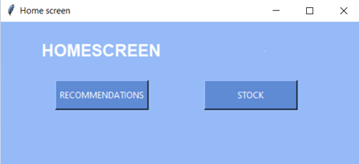

By left clicking on this button the user will be taken to the stock screen and the home screen will be closed.

By left clicking on this button the user will be taken to the recommendations screen and the home screen will be closed.

Allows the user to scroll down the list of product IDs using the mouse of scroll wheel.

Allows the user scroll down the list of Customer IDs using the mouse or scroll wheel.



By left clicking on this button the user will be taken back to the home screen and the recommendation screen will be closed.

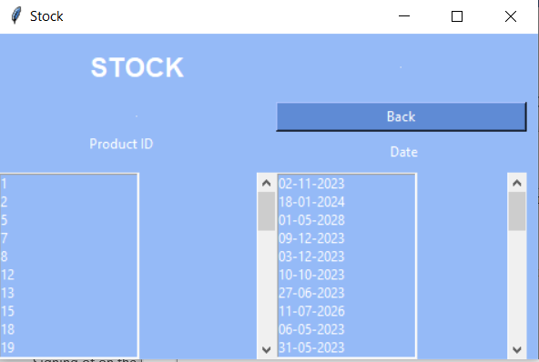

Allows user to scroll through the dates listbox using the mouse or scroll wheel.

By left clicking this button the user will be taken back to the home screen and the stock screen will close

Allows the user to scroll through the product ID list box using the mouse or scroll wheel.

Me: As we discussed in a previous interview the user should be able to navigate through the menus using the mouse and on screen buttons. This has been achieved. The user uses their mouse and their left mouse button to navigate through the different screens. I have also made it clear which buttons lead to what by labelling each button.   
Katherine Northmore: This is good. It gives the user a simple and clear way to navigate through the screens.

### Screen elements



Title to show the user that they are on the home screen.

Title to show the user they are on the recommendations screen.



Heading to show the user that this is the product ID column.

Heading to show the user that this is the customer ID column.

Heading to show the user which screen they’re on.

Heading to show the user that this is the dates column.



Heading to show the user that this is the product ID column.

Me: As discussed in a previous interview the background, buttons and text are all different colours to make it easy for the user to differentiate between them but shades of one colour are used to stop it from becoming confusing to look at. The information is laid out clearly with headings to indicate what is what and there is a title at the top of each screen to indicate which screen the user is on.  
Katherine Northmore: This is also good. The screens look simple and it is easy to understand what you are looking at. I particularly like that there is a title at the top of each screen to make it clear which screen it is.

## How well the solution matches the success criteria

This section is looking at how well the solution matches the requirements created in the research stage.

### Home screen

|  |  |  |  |
| --- | --- | --- | --- |
|  | Requirement | Justification | Reference |
| 3. | Home screen | This will allow the user access the recommendation and stock sections. | Updated requirements interview. |
| 4. | Home screen recommendation and stock options. | This is necessary to allow the user to access the other parts of the program. | Updated requirements interview. |
| 5. | Buttons to access the recommendation screen | This allows the user to interact with the program and is better than the user typing an answer or pressing a key as there is less room for mistypes. | Initial requirements interview. |
| 6. | Button to access the stock screen. | This allows the user to interact with the program and is better than the user typing an answer or pressing a key as there is less room for mistypes. | Initial requirements interview. |
| 7. | Different colours and shades for the background, buttons, search bar and text | This will make it easier for the user to use as it will be more readable and easier to distinguish between background, buttons and the search bars. | Updated requirements interview |

These requirements were met. When the program is run the home screen is displayed. There are two buttons on the home screen which are labelled as stock and recommendations and display the stock and recommendation screen respectively when clicked. Text, back ground and buttons are different colours to make it easy to navigate.

### Recommendations screen

|  |  |  |  |
| --- | --- | --- | --- |
|  | Requirement | Justification | Reference |
| 7. | Different colours and shades for the background, buttons, search bar and text | This will make it easier for the user to use as it will be more readable and easier to distinguish between background, buttons and the search bars. | Updated requirements interview |
| 8. | Search bar | This will allow the user to find customers and products quickly | Updated requirements interview |
| 9. | Back button to access the home screen from the recommendation screen. | This will allow the user to go back to the home screen and access other sections without having to exit the program. | Proposed solution. |
| 12. | Recommendation screen | This will allow the recommendation information to be displayed. | Initial requirements interview. |

The only requirement for this section that was not met is 8. Search bar. This requirement is not met because of the limitations of the Tkinter listbox widget. It is possible to search a list box and only display the items that match or contain the words searched for however, it will only affect what is displayed in one listbox. This means that in my program if the user was to search the customer ID list then the matching customer ID would be displayed but the items in the recommendations box wouldn’t change. This is not what was wanted for the search box as the point of it was it make it easier for the user to find a certain customer and the products that customer should be recommended. Requirement 7 was met as the background, buttons and text are different colours. Requirement 10 was met as there is a back button on the recommendation screen which when clicked closes the recommendation screen and opens the home screen. Requirement 14 was met as when the recommendation button on the home screen is clicked, the home screen closes and the recommendation screen opens.

### Stock screen

|  |  |  |  |
| --- | --- | --- | --- |
|  | Requirement | Justification | Reference |
| 7. | Different colours and shades for the background, buttons, search bar and text | This will make it easier for the user to use as it will be more readable and easier to distinguish between background, buttons and the search bars. | Updated requirements interview |
| 8. | Search bar | This will allow the user to find customers and products quickly | Updated requirements interview |
| 10. | Back button to access the home screen from the stock screen. | This will allow the user to go back to the home screen and access other sections without having to exit the program. | Proposed solution. |
| 14. | Stock screen | This will allow the stock information to be displayed for the user. | Initial requirements interview. |

The only requirement for this section that was not met is 8. Search bar. This requirement is not met because of the limitations of the Tkinter listbox widget. It is possible to search a list box and only display the items that match or contain the words searched for however, it will only affect what is displayed in one listbox. This means that in my program if the user was to search the product ID list then the matching product ID would be displayed but the items in the date box wouldn’t change. This is not what was wanted for the search box as the point of it was it make it easier for the user to find a certain product and date the product will run out on. Requirement 7 was met as the background, buttons and text are different colours. Requirement 10 was met as there is a back button on the stock screen which when clicked closes the stock screen and opens the home screen. Requirement 14 was met as when the stock button on the home screen is clicked, the home screen closes and the stock screen opens.

### Recommendation algorithm

|  |  |  |  |
| --- | --- | --- | --- |
|  | Requirement | Justification | Reference |
| 1. | Item-based collaborative filtering | This will find recommendation with limited customer data. | Amazon recommendation engine. |
| 2. | Cosine similarity | This will find how similar products are allowing for recommendations to be made | Features of the proposed solution. |
| 13. | List of customers and products they should be recommended | This will allow the user to see which products to recommend to which customers. | Initial requirements interview. |
| 16. | CSV file link | This will allow the algorithms to use data from the CSV files to make predictions and recommendations. | Proposed solution. |

The only requirement that was not met for this section is 2. Cosine similarity. When using cosine similarity I got an error when trying to create a product similarity data frame, I am still unsure why this error occurred but I found that I did not get this error when using Pearson correlation. Requirement 1 is met as recommendations are found by finding how similar the products are by using their ratings and then recommending customers products that are similar to ones they have already bought. Requirement 13 is met as when products that should be recommended are found, the customer ID of the customer they should be recommended to is added to the customer ID list and the product ID of the product they should be recommended is added to the product ID list. Requirement 16 is met as it is possible to link a CSV file to the program to use that data. However, it is somewhat limited as the only way to link the file is to access the code itself. To allow the user to link a file without doing this I would find a way to let the user type the address of the file they wish to use into the recommendation screen and have the program use the file at that location. I would also make it clear what data is required to prevent any confusion for the user.

### Stock prediction algorithm

|  |  |  |  |
| --- | --- | --- | --- |
|  | Requirement | Justification | Reference |
| 11. | Predictive analysis algorithm | This will analyse sales data to predict when stock will run out. | Proposed solution. |
| 15. | List of products and the date they will run out | This will allow the user to see when each product will run out. | Initial requirements interview. |
| 16. | CSV file link | This will allow the algorithms to use data from the CSV files to make predictions and recommendations. | Proposed solution. |

All of these requirement have been met. Requirement 11 has been met as the sales data is looked at to make predictions as to when the product will run out. However, it is somewhat limited as the algorithm is very simplistic and assumes that the same number of products were bought every day over the 30 day period and so doesn’t account for times when many items were bought in one day. To resolve this I would look at creating a more complex predictive analysis algorithm that can take the distribution of when items were purchased into consideration. Requirement 15 is met as when the date a product is expected to run out is found, the product ID is added to the product ID list and the data is added to the date list. Requirement 16 is met as it is possible to link a CSV file/files to the program to use that data. However, it is somewhat limited as the only way to link the file is to access the code itself.

## Maintenance

### Current and future maintenance

No maintenance features have been implemented into my code. This would need to be addressed if the program was going to be distributed to users as bugs may be found and the program may need updating. There would need to be a way for user to report and bugs they come across so I would add a help button in the corner of each of the three screens which when clicked takes the user to a form they can fill in to describe the issue they have found.

It will also need to be possible to make the user aware of any updates that have been made. At the top of the home screen I would put a message telling the user if they are using the latest version of the program or not. If they are using the latest version it would just say that they are using the latest version and what the latest version is. If they were not using the latest version it would say which version they are using, what the latest version is and warn them that they may run into errors that have been addressed in the latest version is they continue to use an older version. I would also add instruction on how to update the program. These would be found when the use clicked on the help button in the corner.

Since I have used libraries when developing the solution, it relies on the libraries being maintained so part of future maintenance would involve checking that these libraries have been maintained and possibly reducing the use of libraries to prevent the potential lack of library maintenance from becoming a problem.

### Limitations and how they would be approached

|  |  |  |  |
| --- | --- | --- | --- |
|  | Requirement | Justification | Reference |
| 16. | CSV file link | This will allow the algorithms to use data from the CSV files to make predictions and recommendations. | Proposed solution. |

While this requirement has been met, it is not possible for the user to link their CSV files to the program without accessing the code itself. This is no idea as it requires the user to access the code making the program more complex to use. It also requires that the user has some understanding of python as they will need to know how to link CSV files to a program to link their own files. To allow the user to link a file without doing this I would find a way to let the user type the address of the file they wish to use into the stock screen and have the program use the file at that location. I would also make it clear what data is required to prevent any confusion for the user.

|  |  |  |  |
| --- | --- | --- | --- |
|  | Requirement | Justification | Reference |
| 2. | Cosine similarity | This will find how similar products are allowing for recommendations to be made | Features of the proposed solution. |

When using cosine similarity to find how similar products are I get an error when trying to create a product similarity data frame. I am unsure why this created an error but after tracing the error back to my use of cosine similarity, I found that using Pearson correlation worked and still allowed for recommendations to be made. However, Pearson correlation is not as good for working on a sparse data set as cosine similarity is. This means it requires products to have more ratings to find the similarity between product than cosine similarity does which is not ideal as the user may only have a few ratings if their business if new or if they have added new items. To solve this problem I would first find out why using cosine similarity was resulting in an error when trying to create a product similarity data frame and then find possible ways around what is causing the error. If it is not possible to avoid the problem using cosine similarity, I would find another way of finding the similarity that also works well on sparse data sets.

|  |  |  |  |
| --- | --- | --- | --- |
|  | Requirement | Justification | Reference |
| 8. | Search bar | This will allow the user to find customers and products quickly | Updated requirements interview |

While it is possible to search a listbox in Tkinter, I could not find a way for both listboxes to be affected, defeating the purpose of having the search bar. To implement this feature I would find a way of either displaying a 2D array in a single listbox or find a way of displaying the data in a clearly laid out and easy to use way that doesn’t require use of a listbox so the problem of only one of the listboxes being searched is removed. I would consider using a different python graphics library as there may be others which have more ways of creating search bars. I would also consider using a different high level language to program the user interface with as they may be better for creating user interfaces and may have ways of creating a search bar with the desired functionality, they may also have libraries that have more options for creating search bars.

One limitation which was no discussed in the success criteria is the dates used. The program will automatically use today’s date and the date 30 days ago to estimate when a product will run out. However, this means that if a product has not been purchased in the last 30 days, it can’t estimate when the product will run out. Also, the user may wish to look within a customisable date range, especially if there are many products which are not frequently sold, and it would be good to give them this option. To address this I would add an entry boxes on the stock screen asking the user which date they wish to be the last date in the 30 day period. I would update the code so that it still defaults to using the current date but will use the date the customer enters as the last day of the 30 day period if something is entered. This would also require a validation feature as the date entered would have to be in a format that matches the way the dates are stored in the CSV file and isn’t in the future.

# Project Appendixes

## Code listings

homescreen.py file

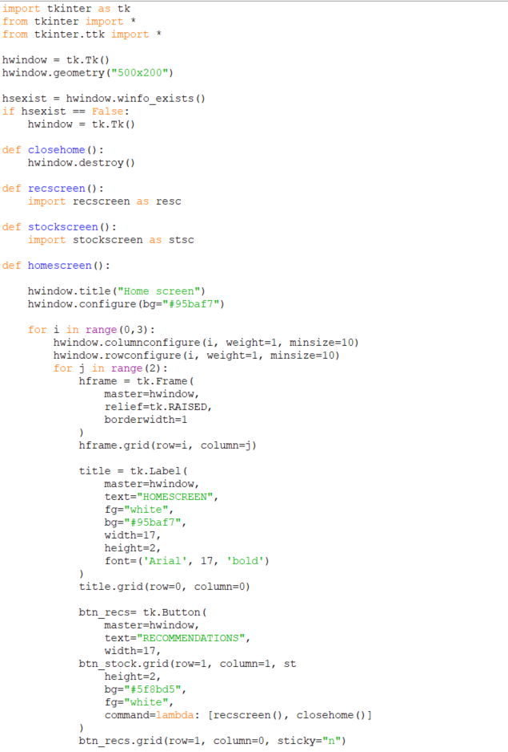

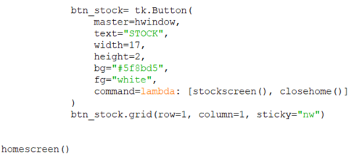

recscreen.py file

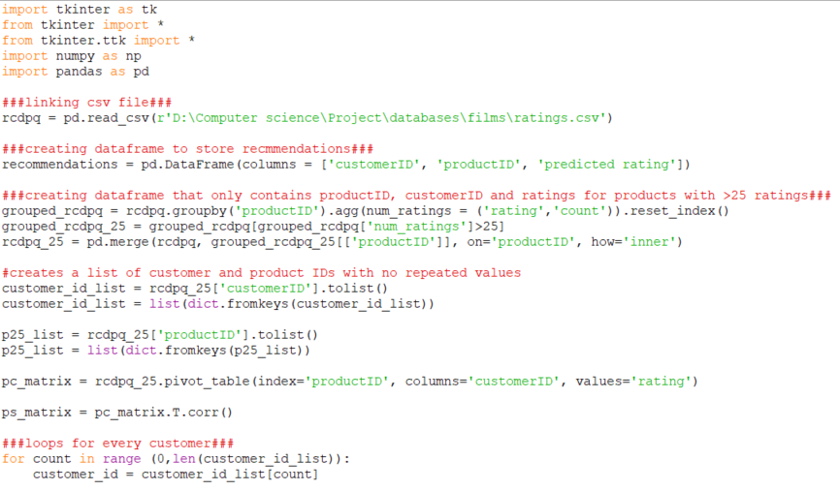

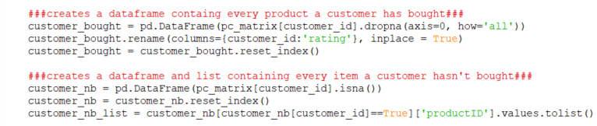



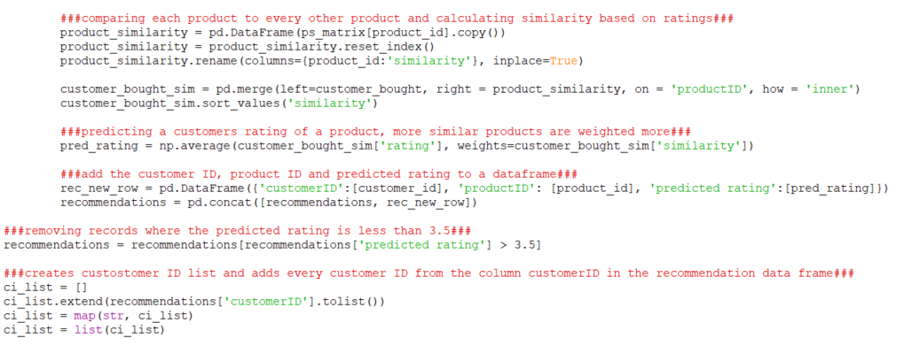

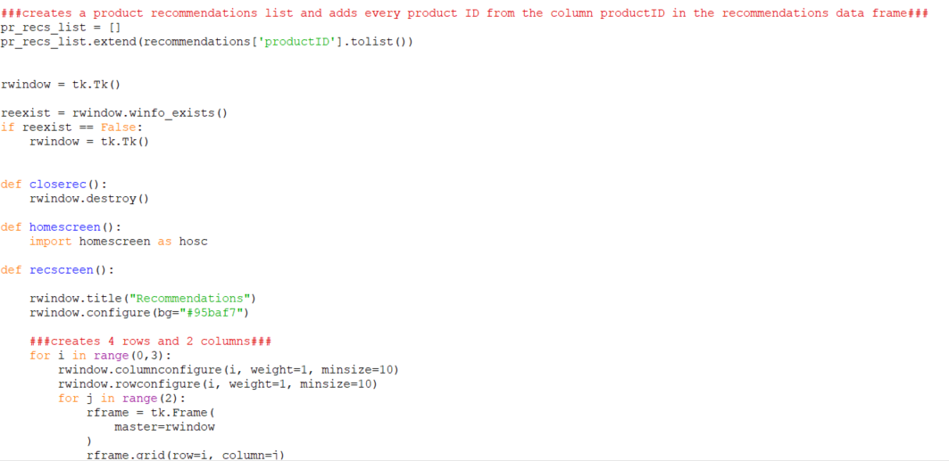  
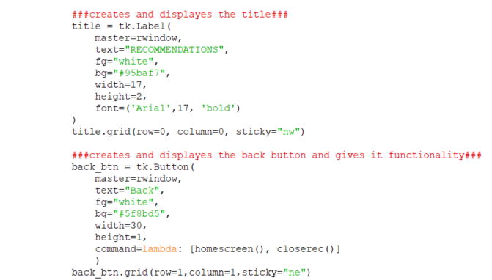

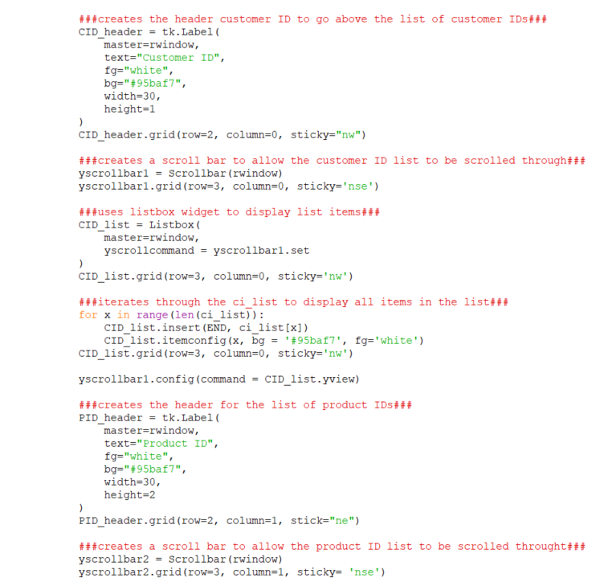  
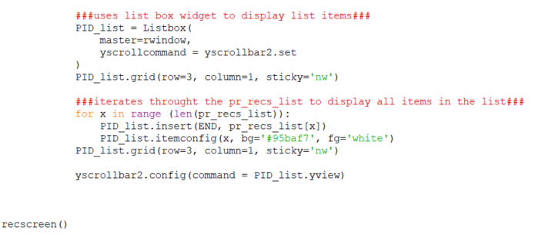

stockscreen.py file

